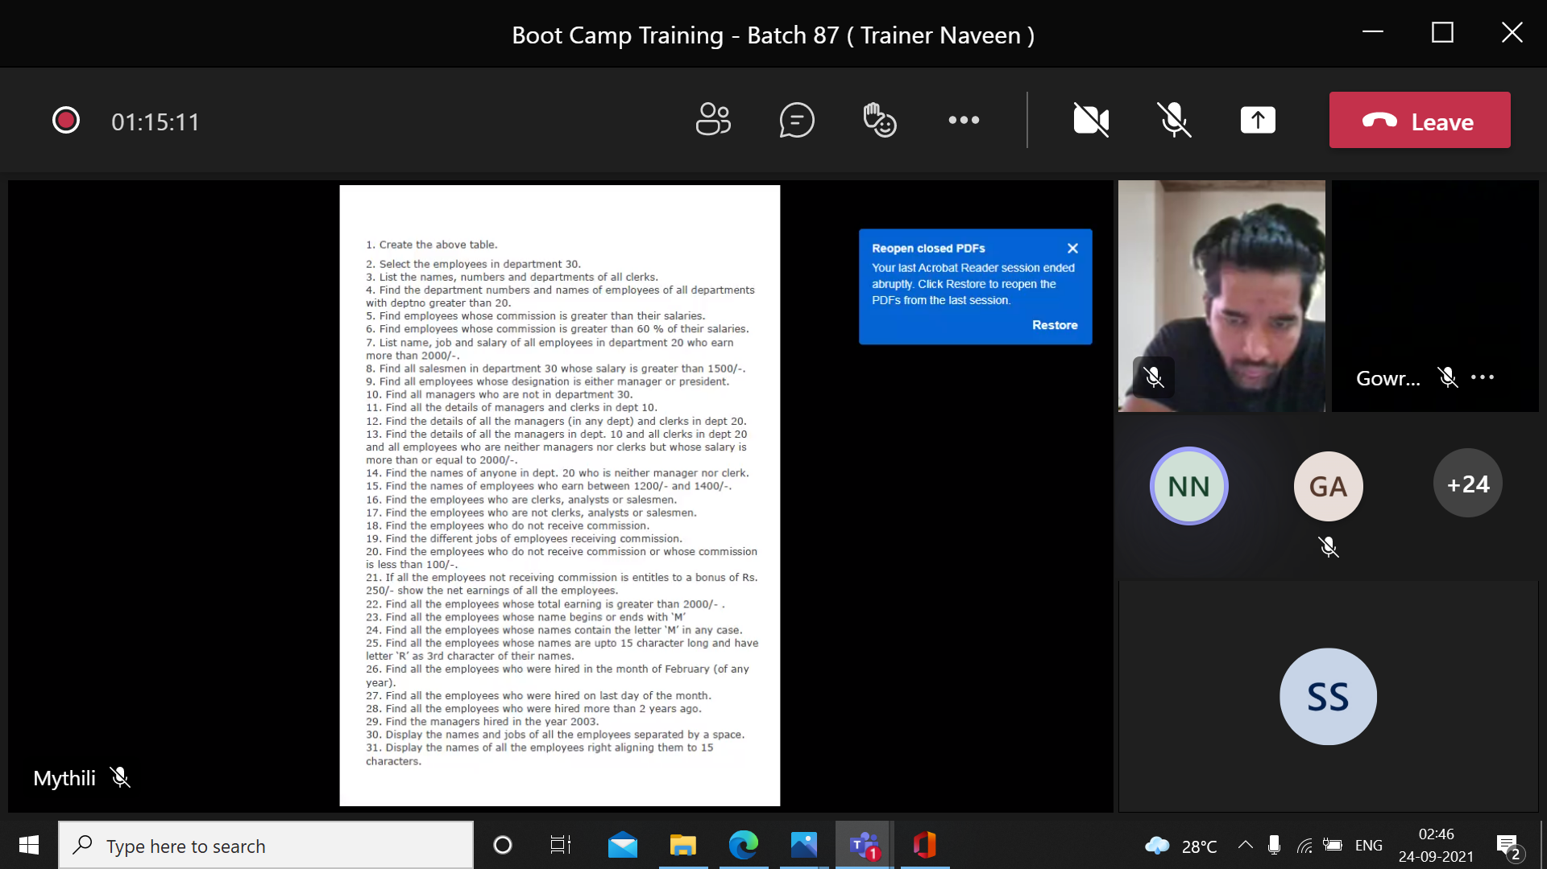

1. Create a table.

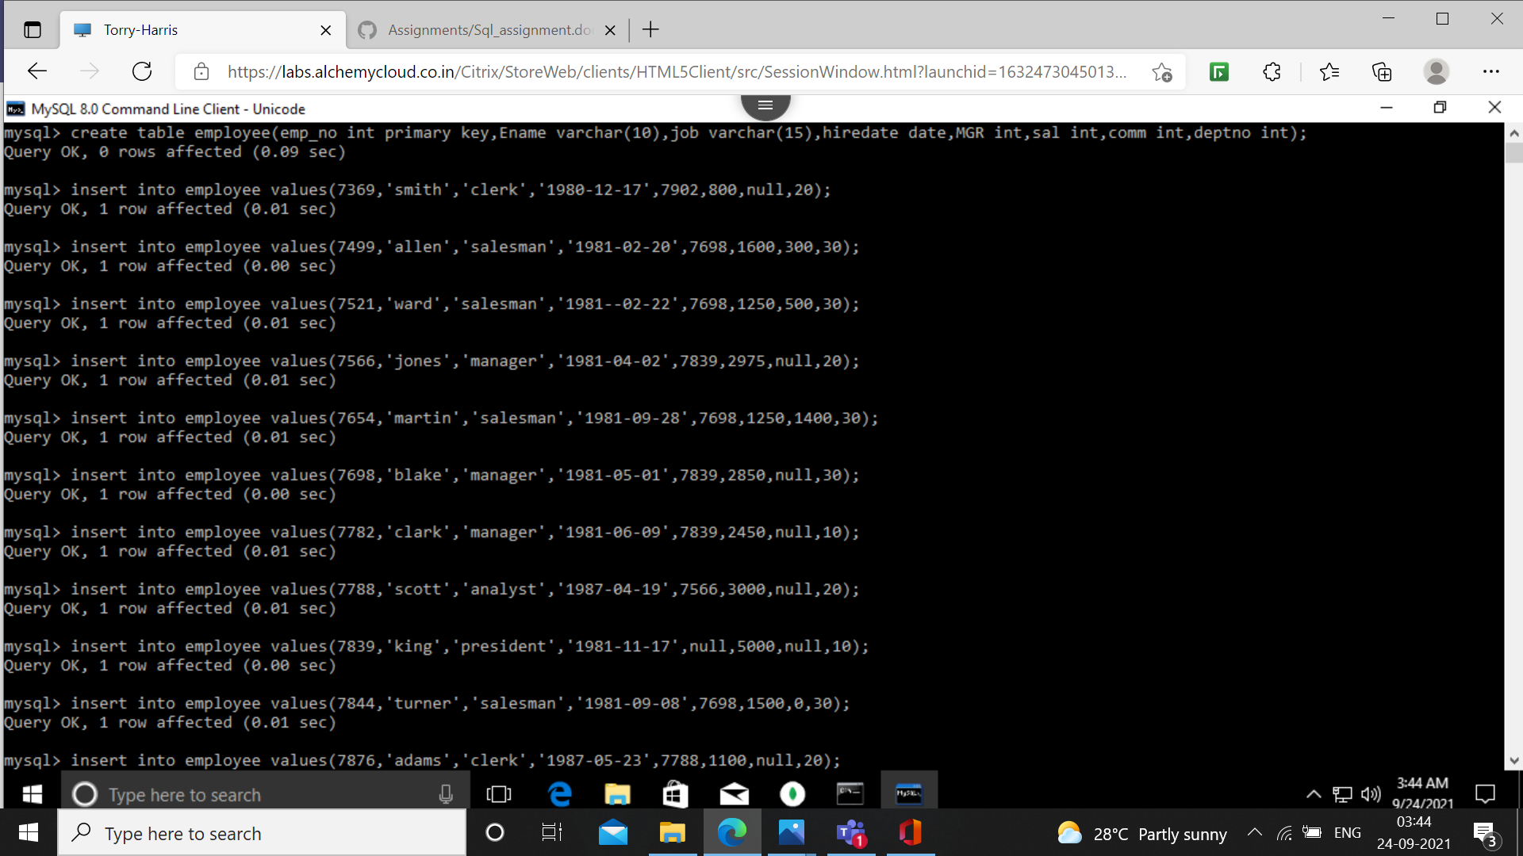

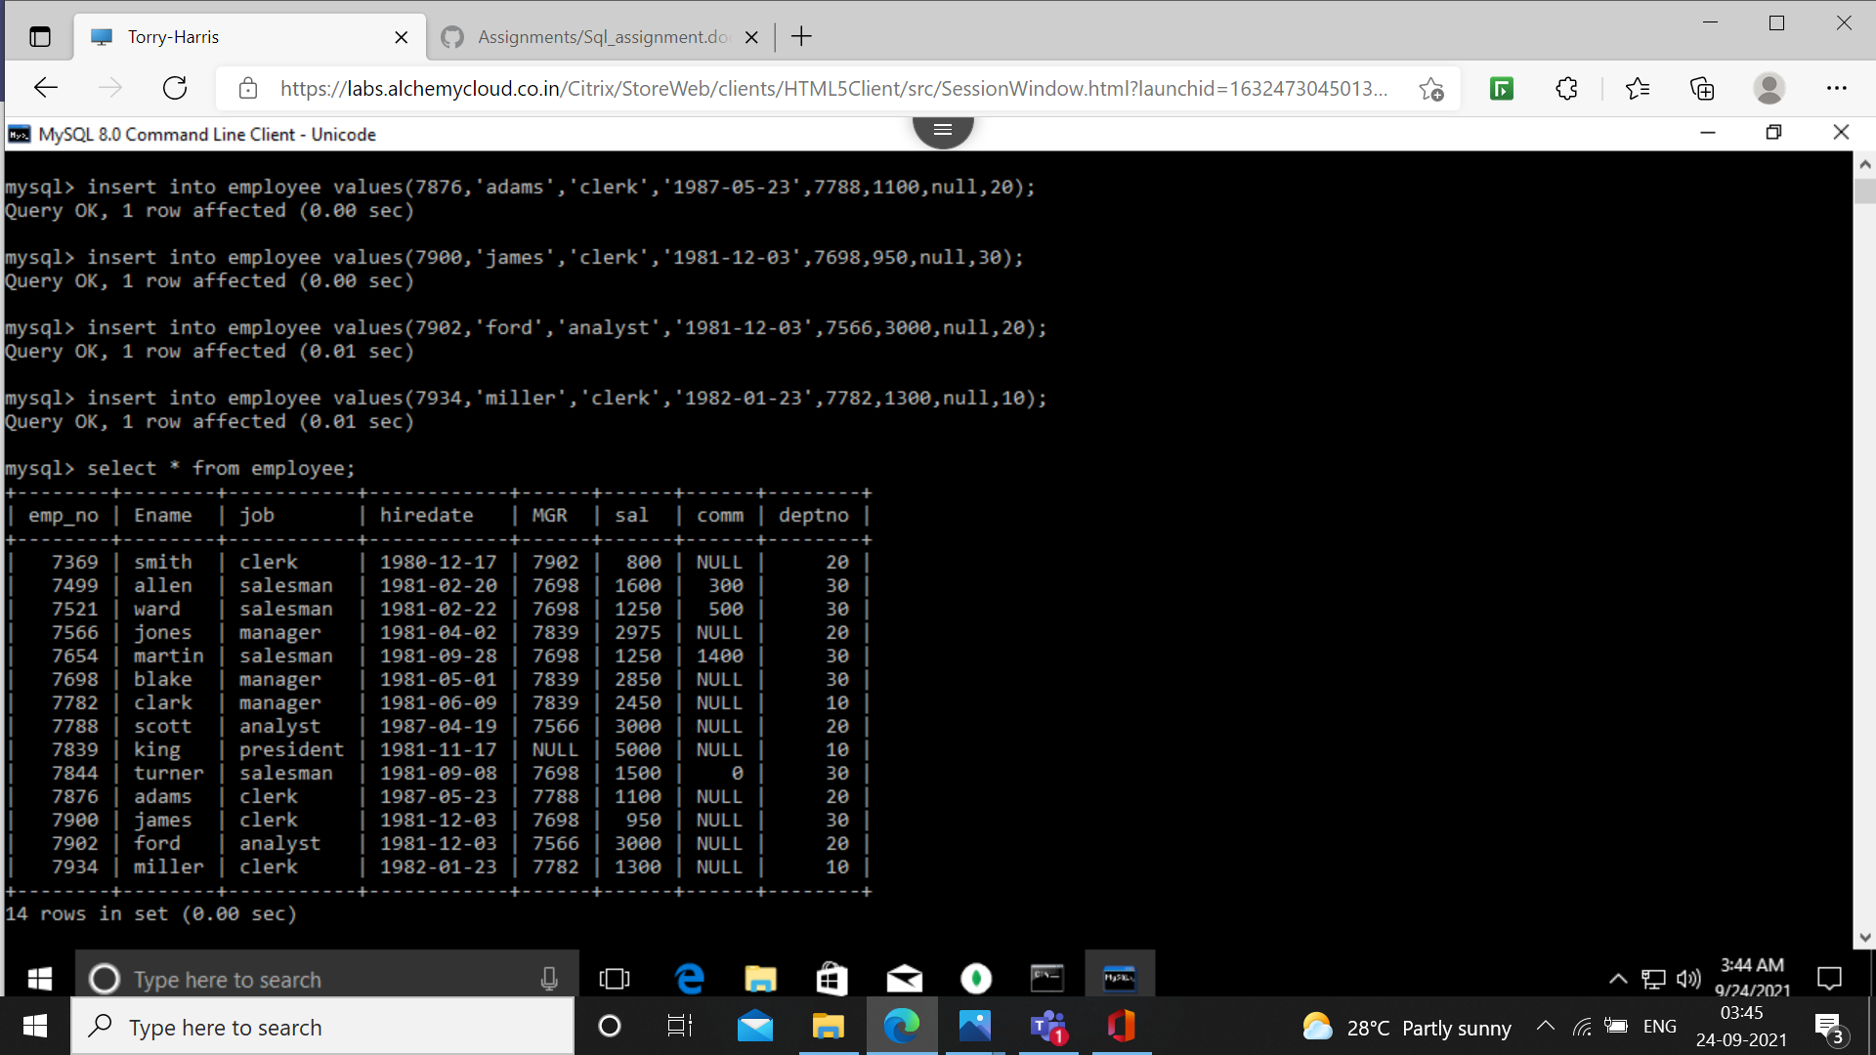

2.select the employees in department 30.

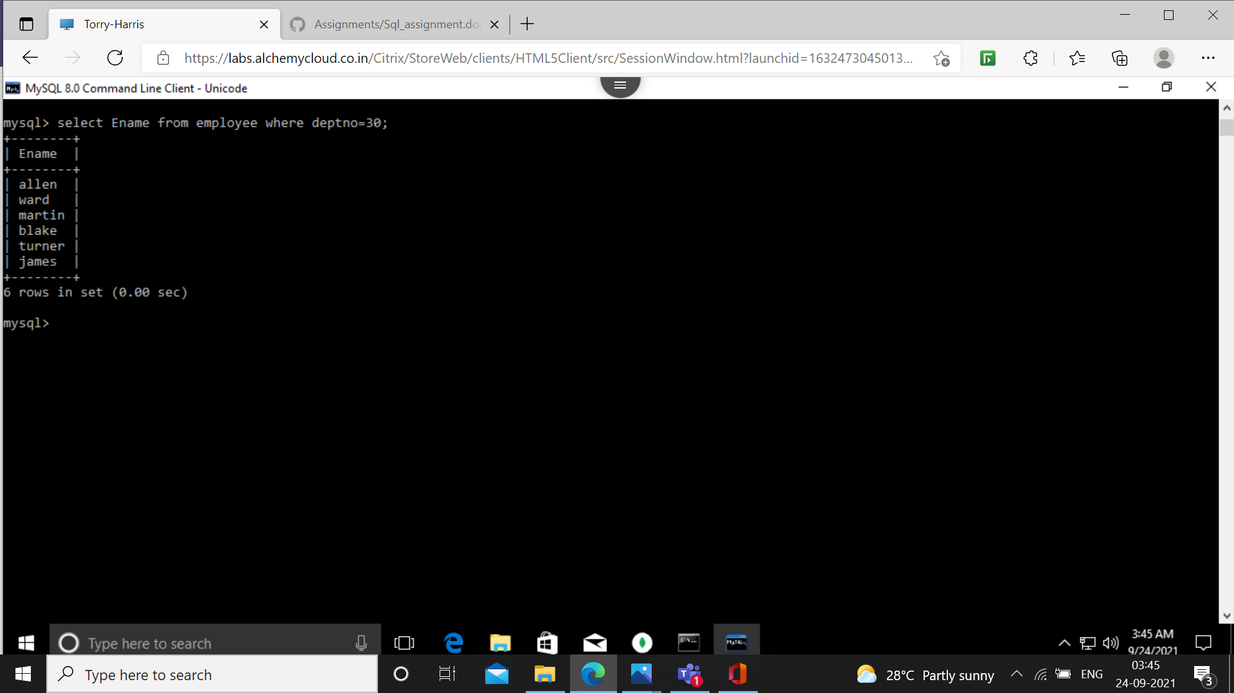

3.list the names, numbers and departments of all clerks.

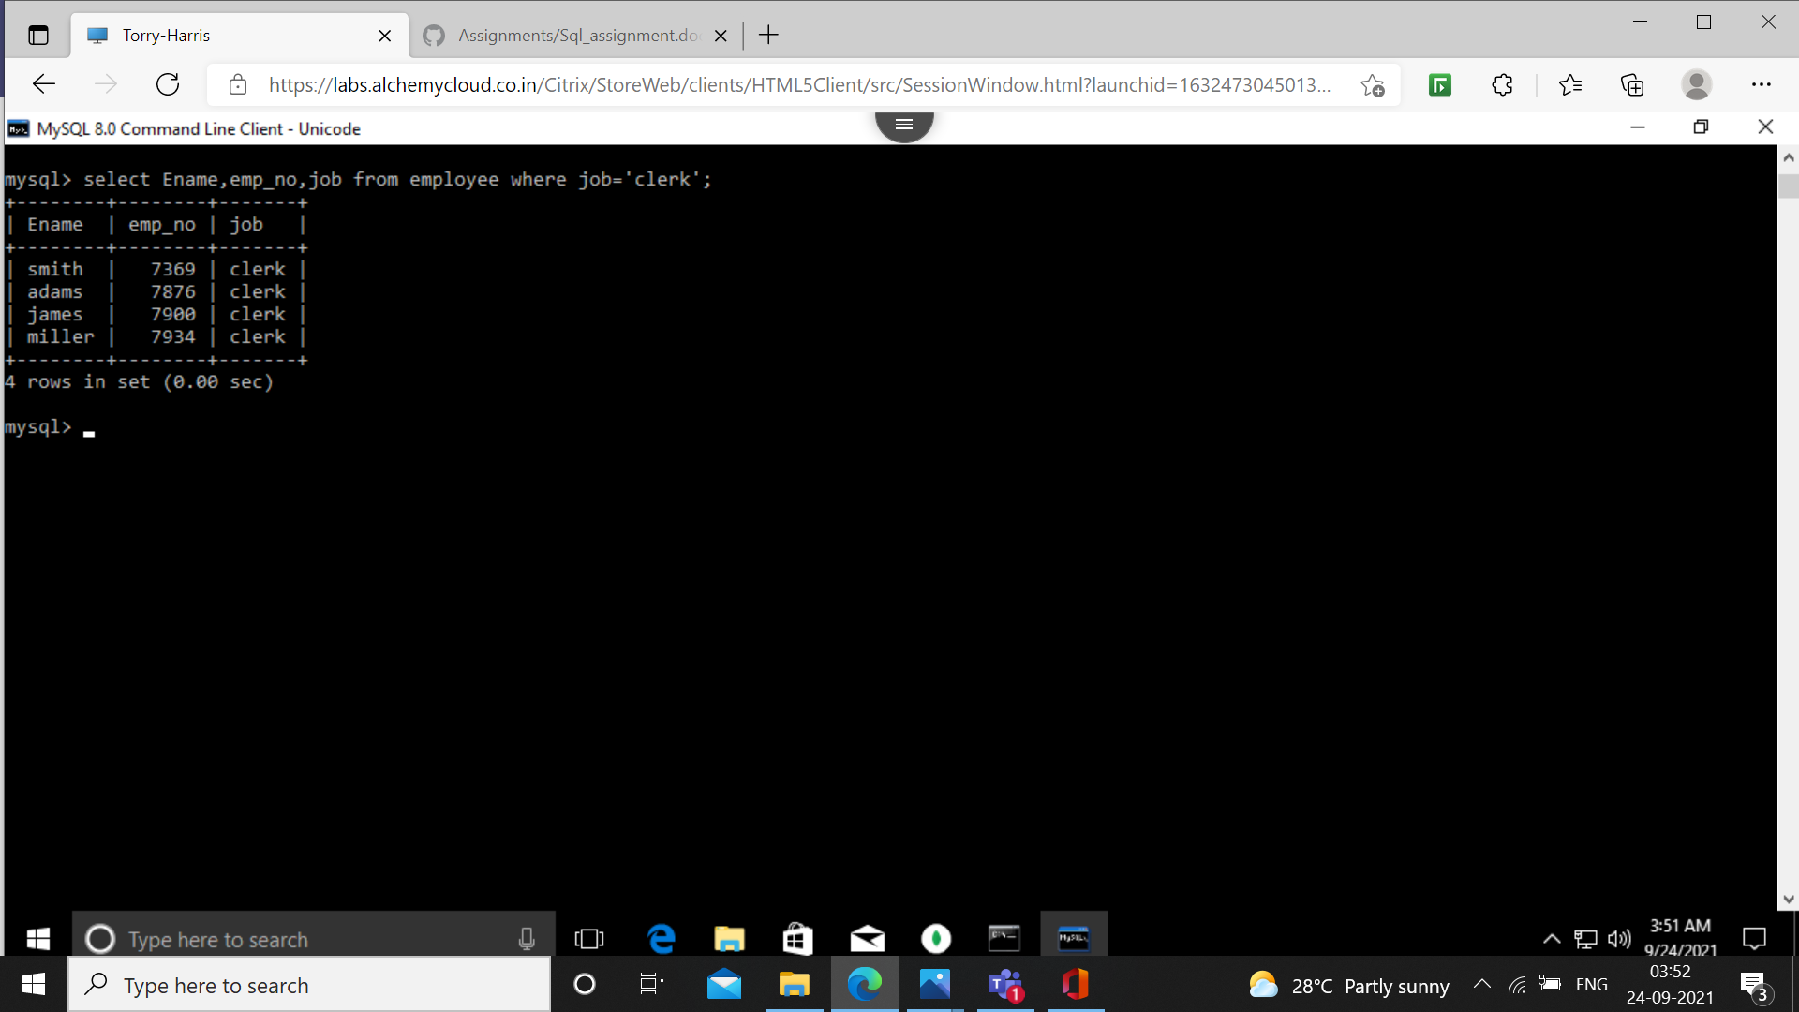

4. find the department numbers and names of employees of all departments with deptno greater than 20.

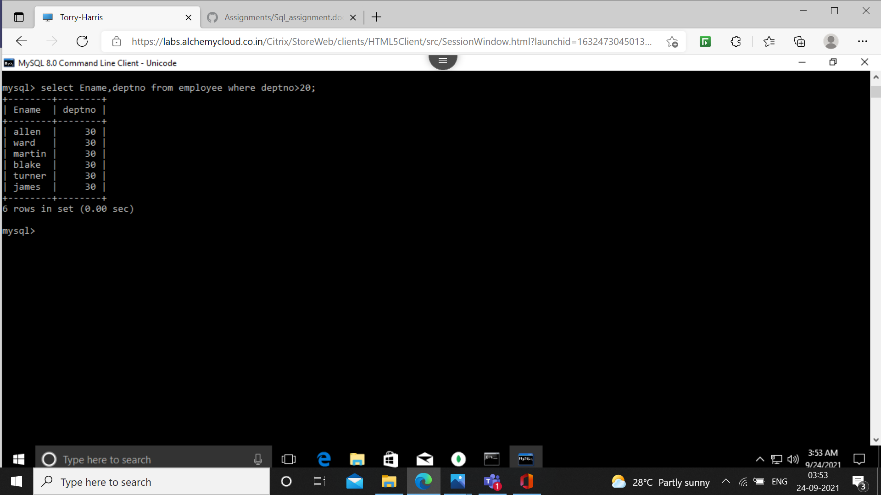

5.find employees whose commission is greater than their salaries.

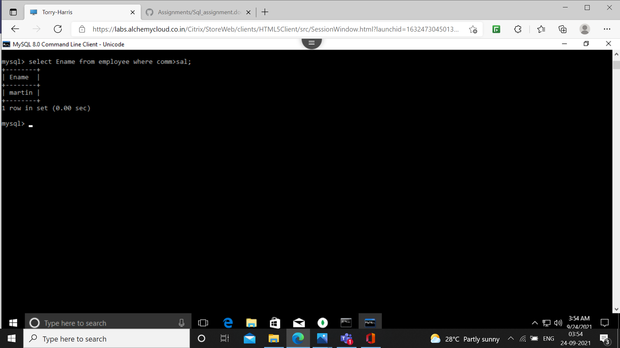

6.find employees whose commission is greater than 60% of their salaries.

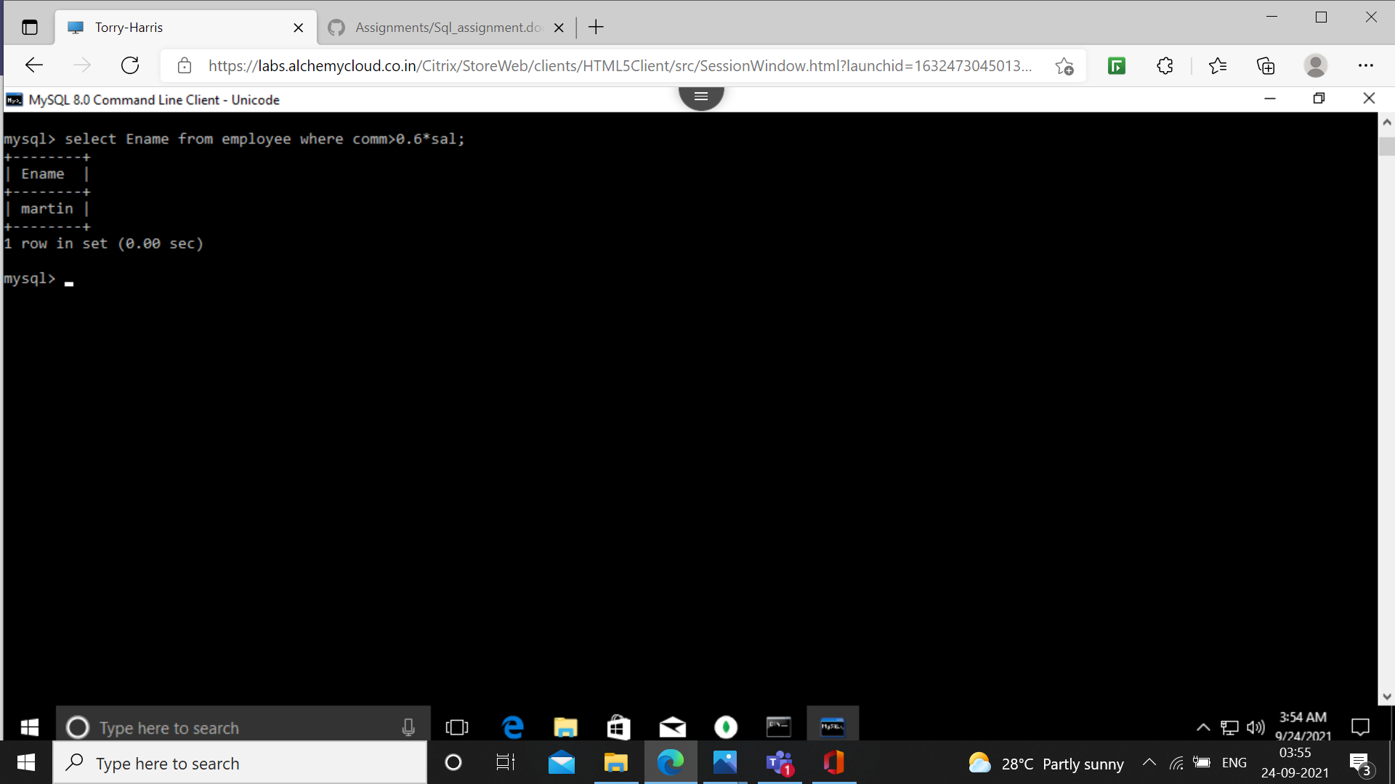

7.list name, job and salary of all employees in dept 20 who earn more than 2000/-

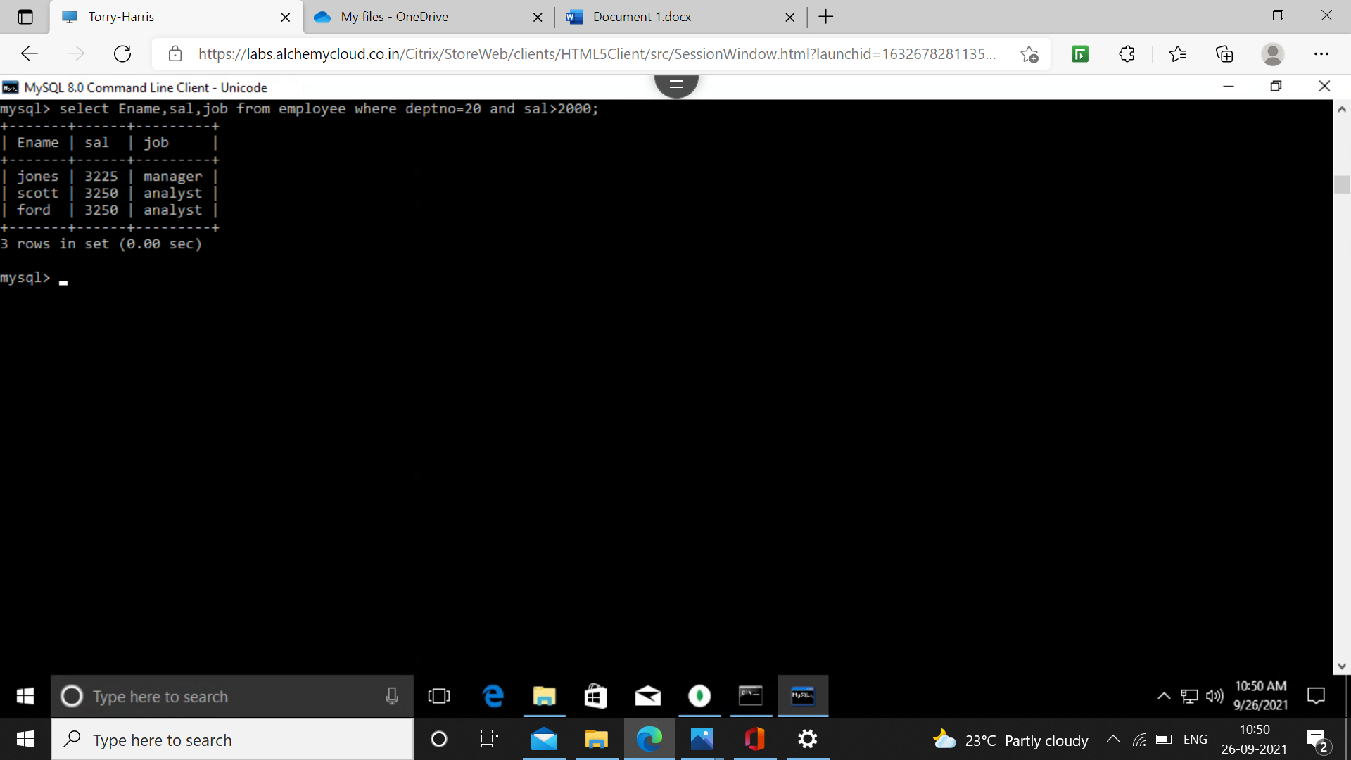

8.find all salesman in department 30 whose salary is greater than 1500/-

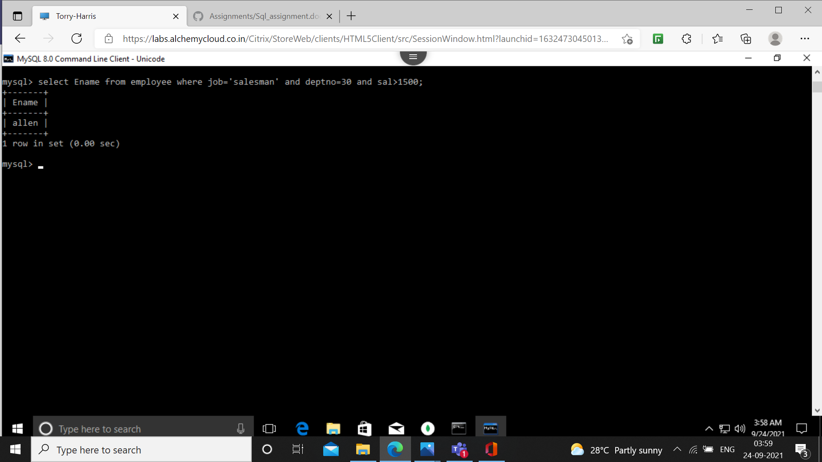

9.find all employees whose designation is either manager or president.

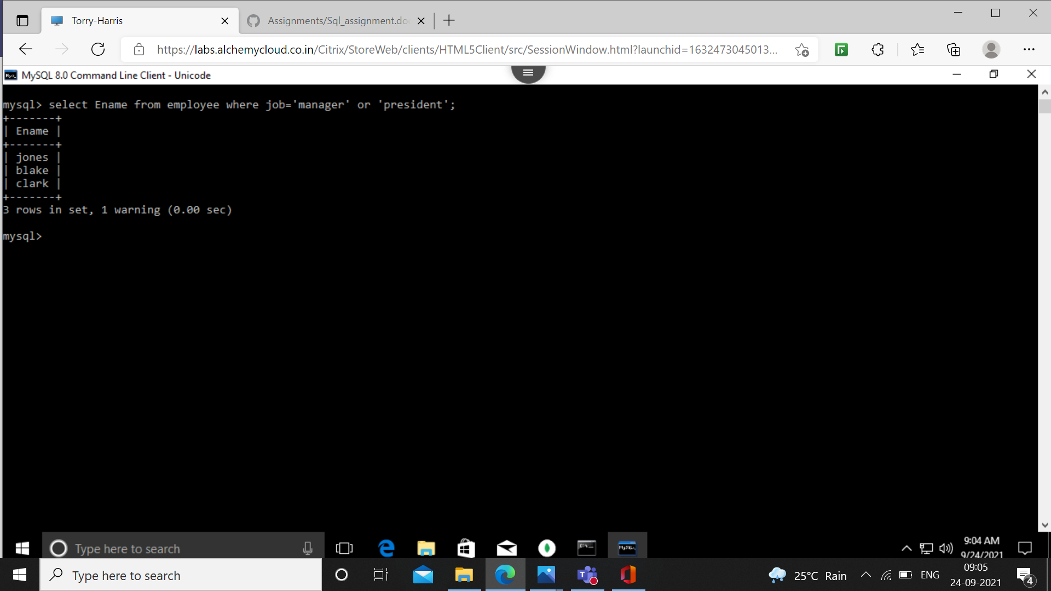

10. Find all managers who are not in department 30.

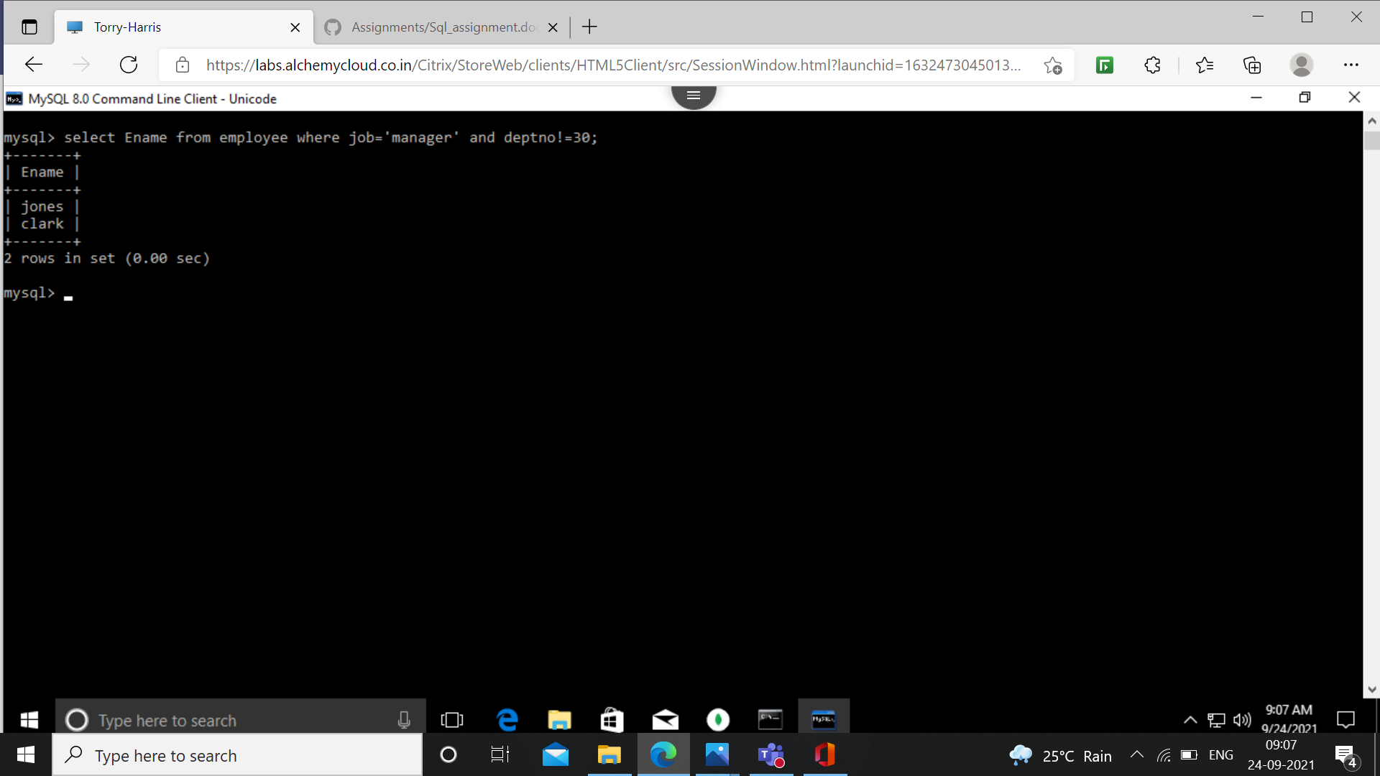

11.find all the details of managers and clerks in department 10.

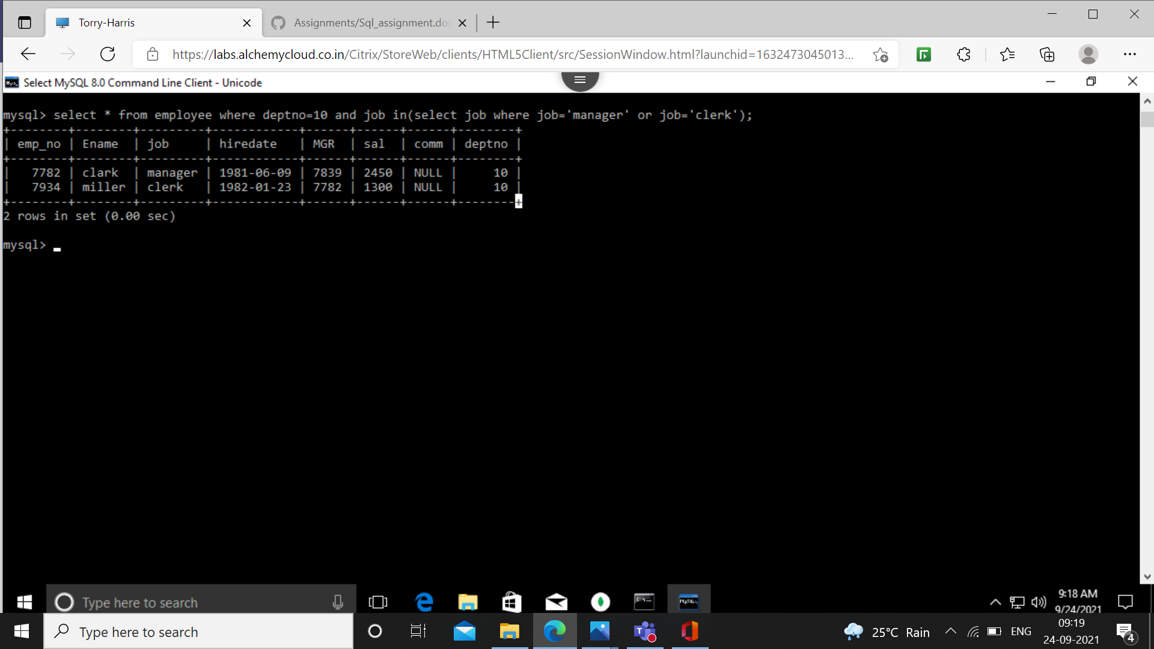

12.find the details of all the managers (in any dept) and clerks in dept 20.

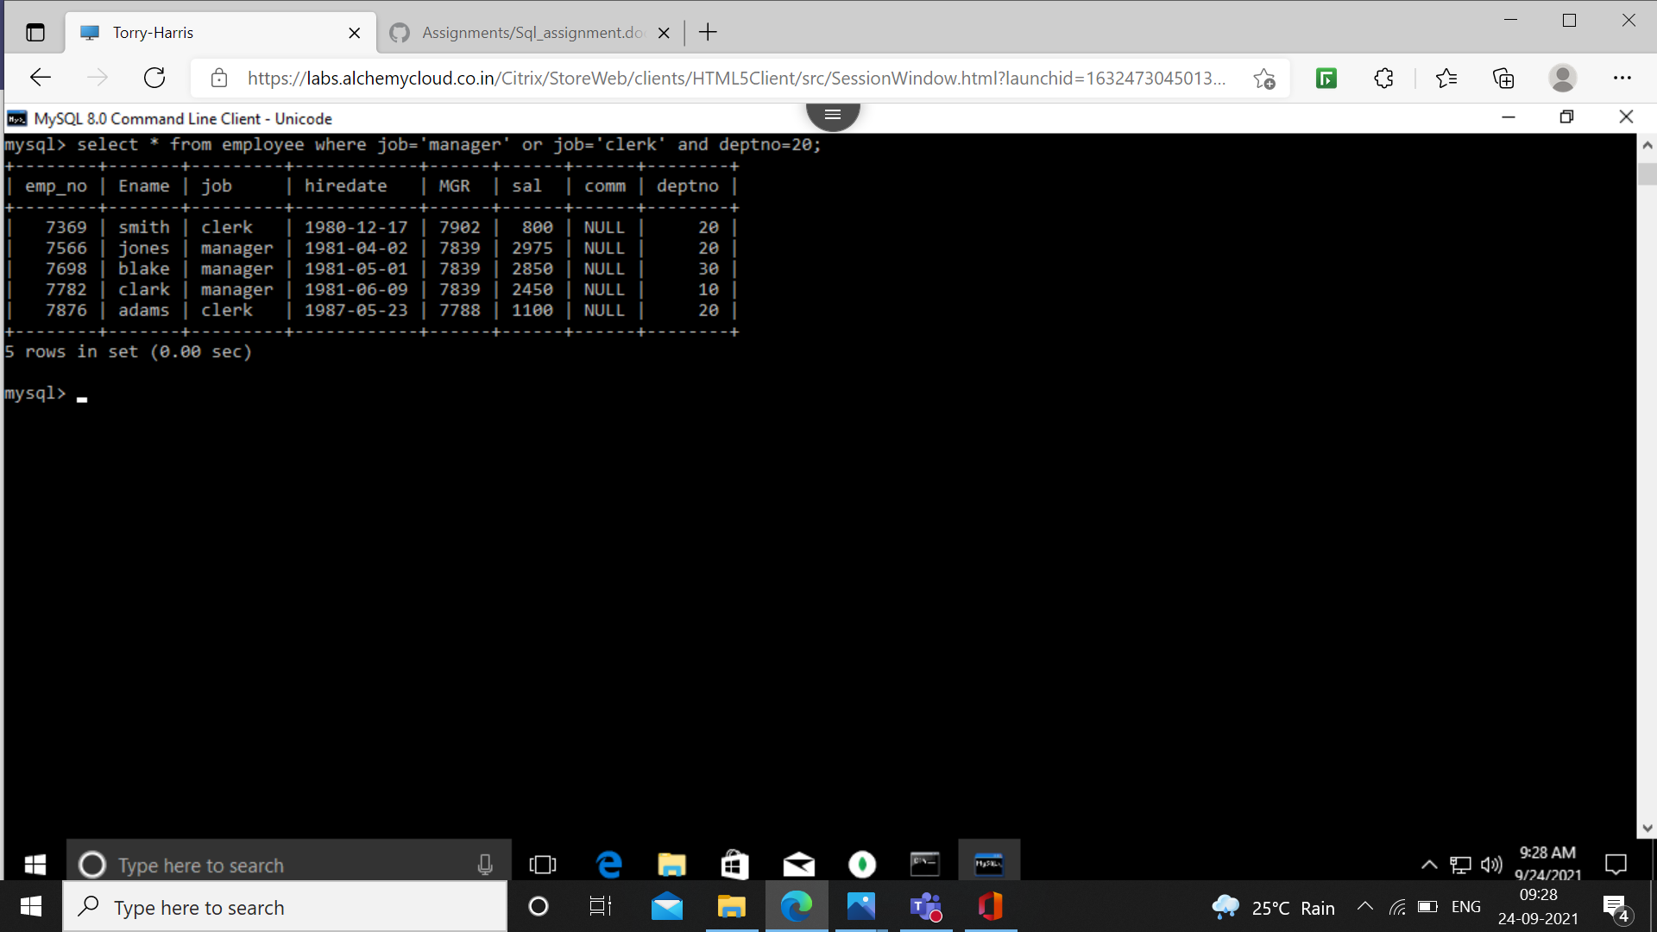

13. Find the details of all managers in dept. 10 and all clerks in deptno 20 and all employees who are neither managers nor clerks but whose salary is greater than r equal to 2000/-

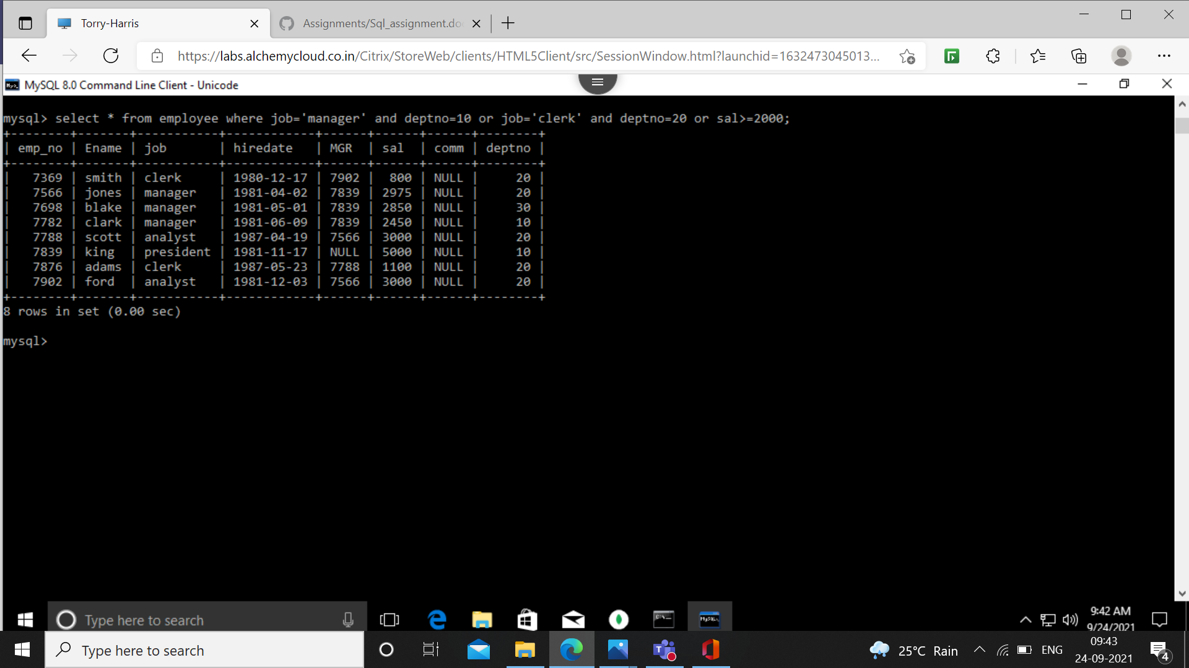

14. Find the names of anyone in dept 20 who is neither manager nor clerk.

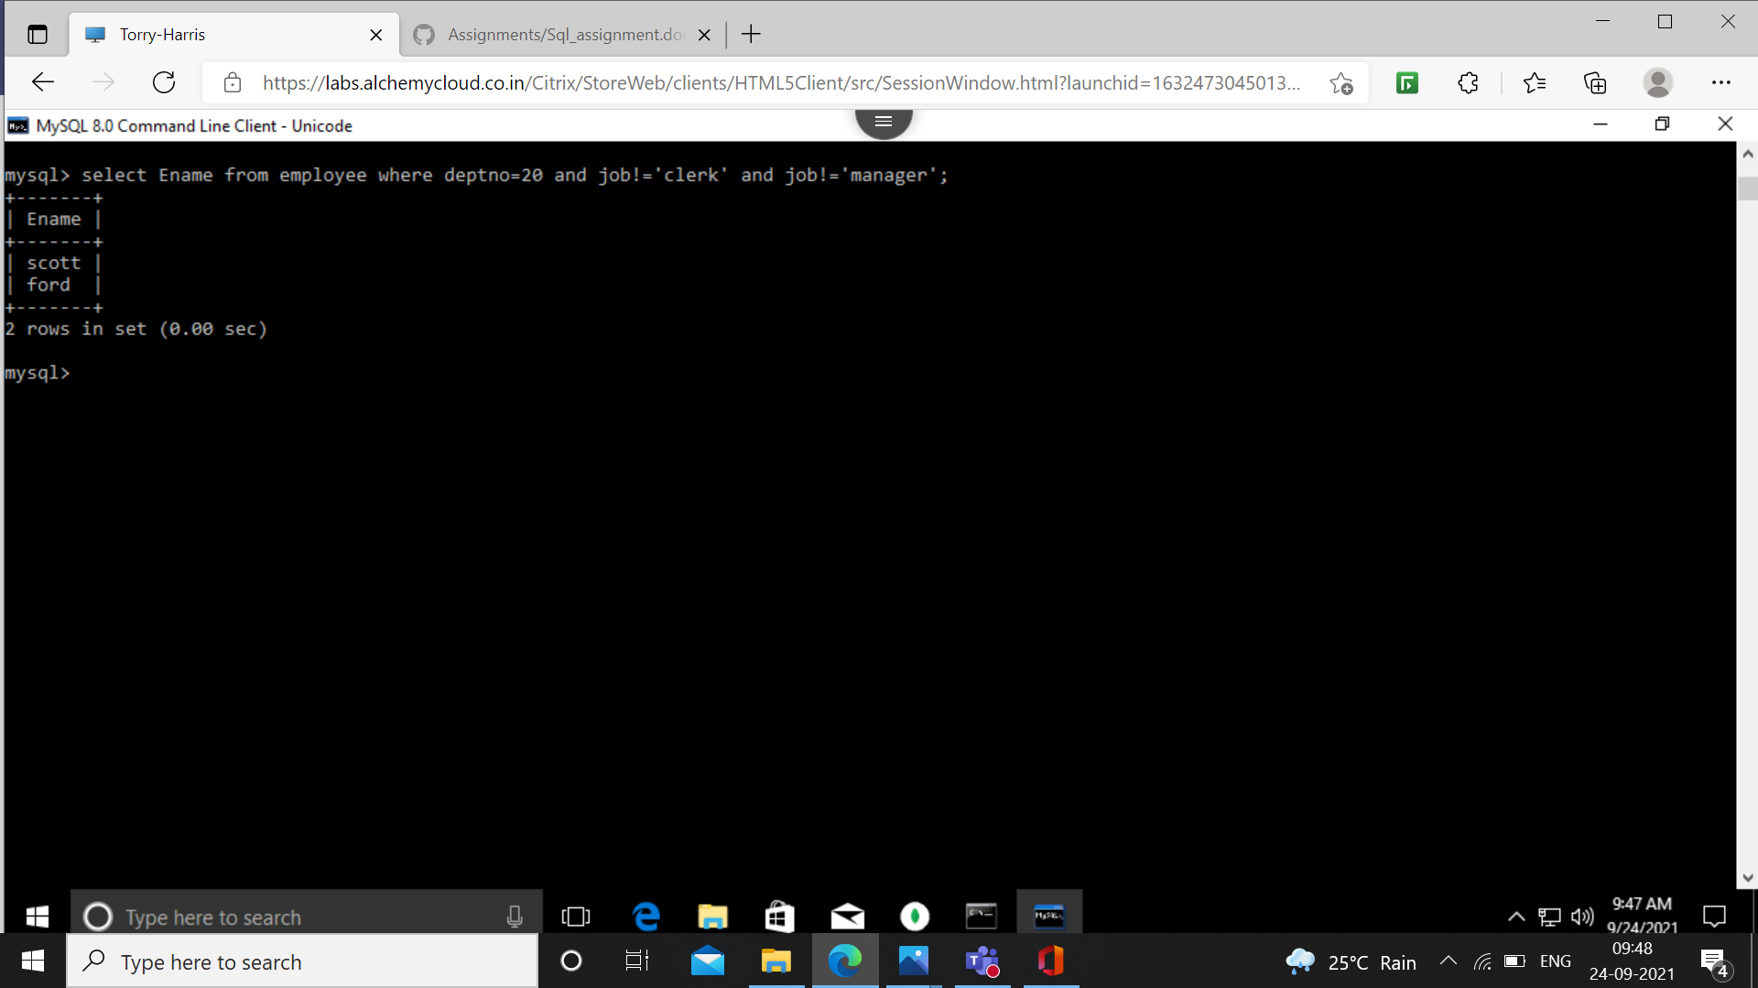

15.find the names of employees who earn between 1200/- and 1400/-

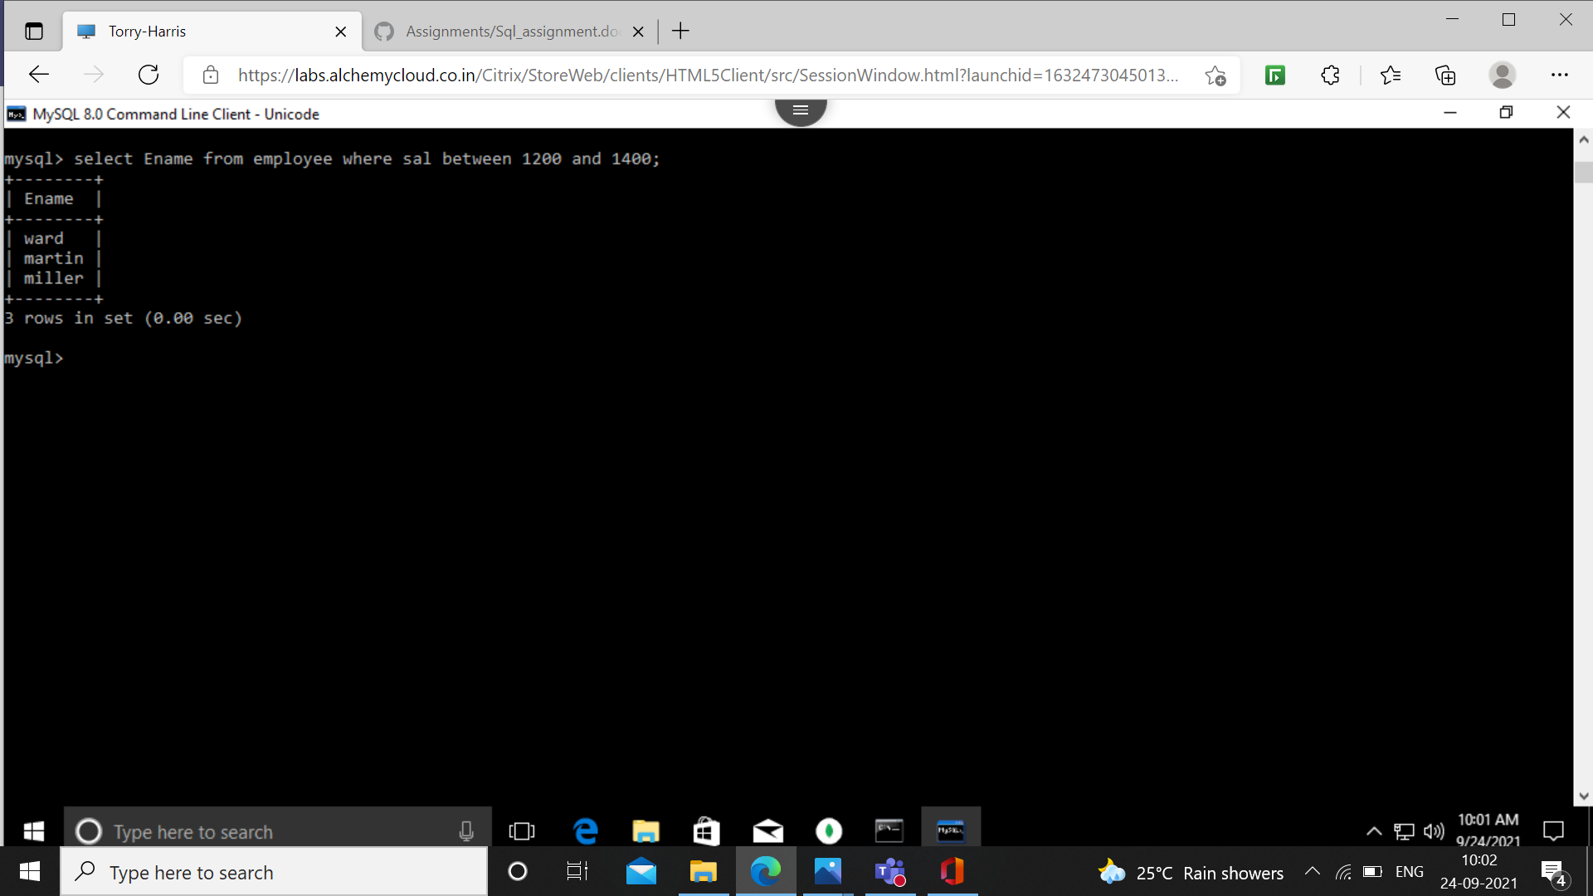

16.find the employees who are clerks, analyst or salesman.

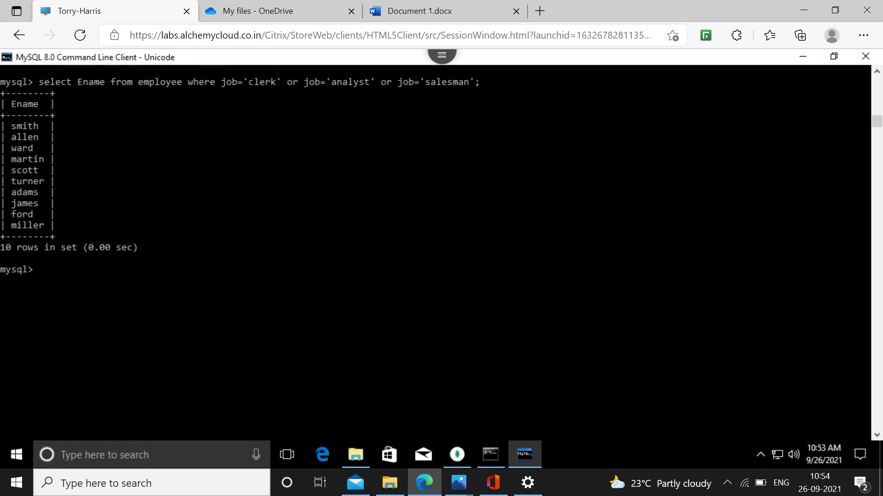

17.find the employees who are not clerks, Aleman or analyst.

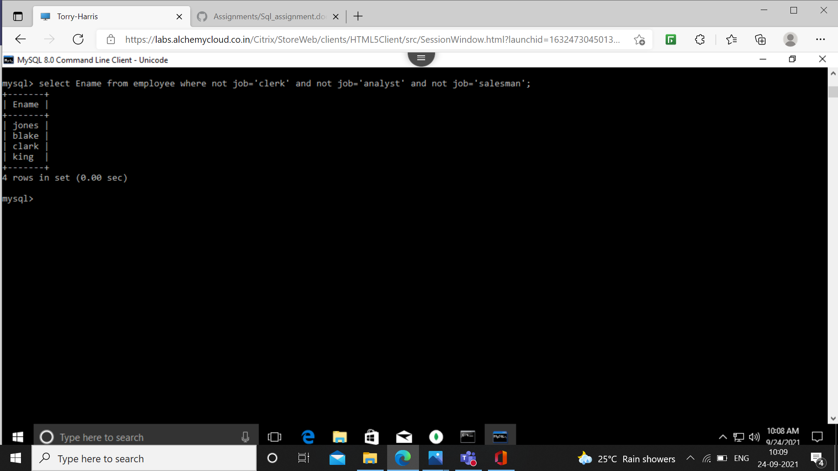

18. Find the employees who do not receive commission.

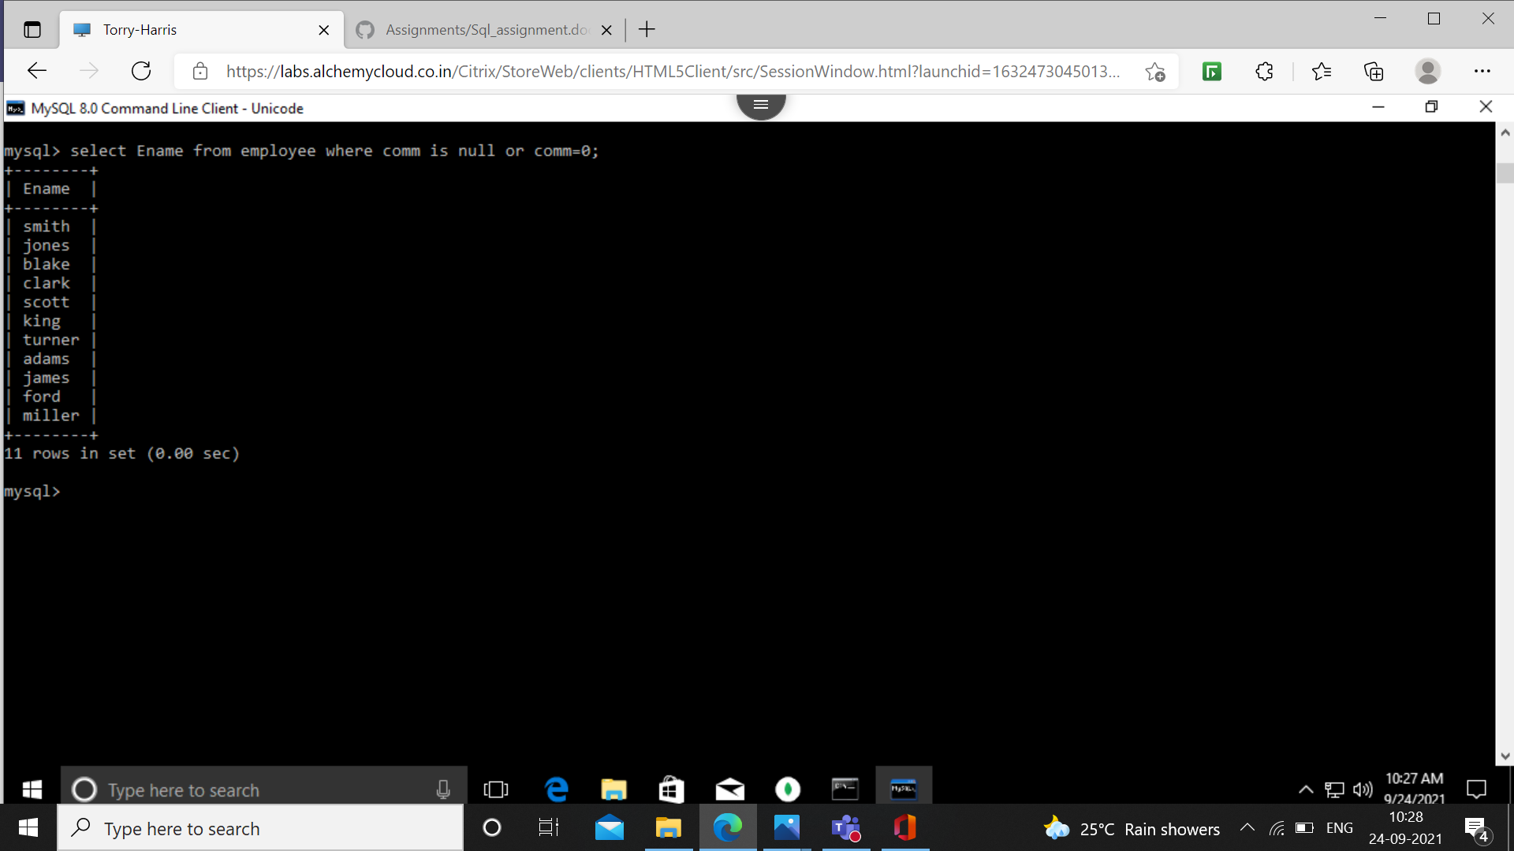

19. Find the different jobs of employees receiving commission.

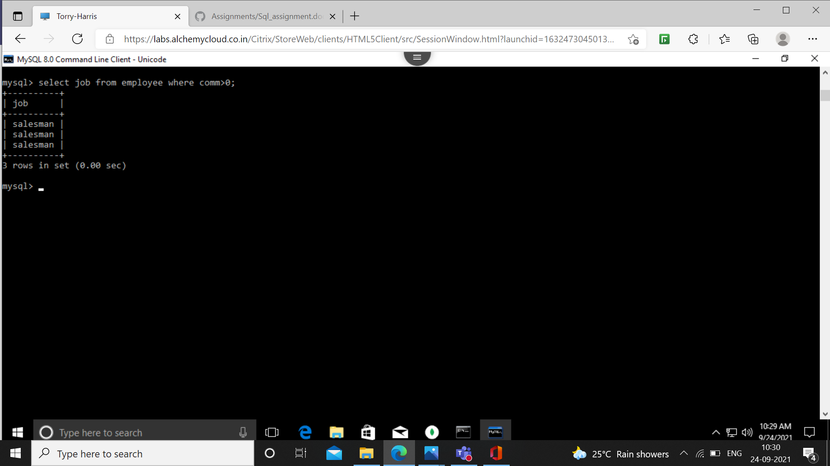

20. Find the employees who do not receive Commision or whose Commision is less than 100.-

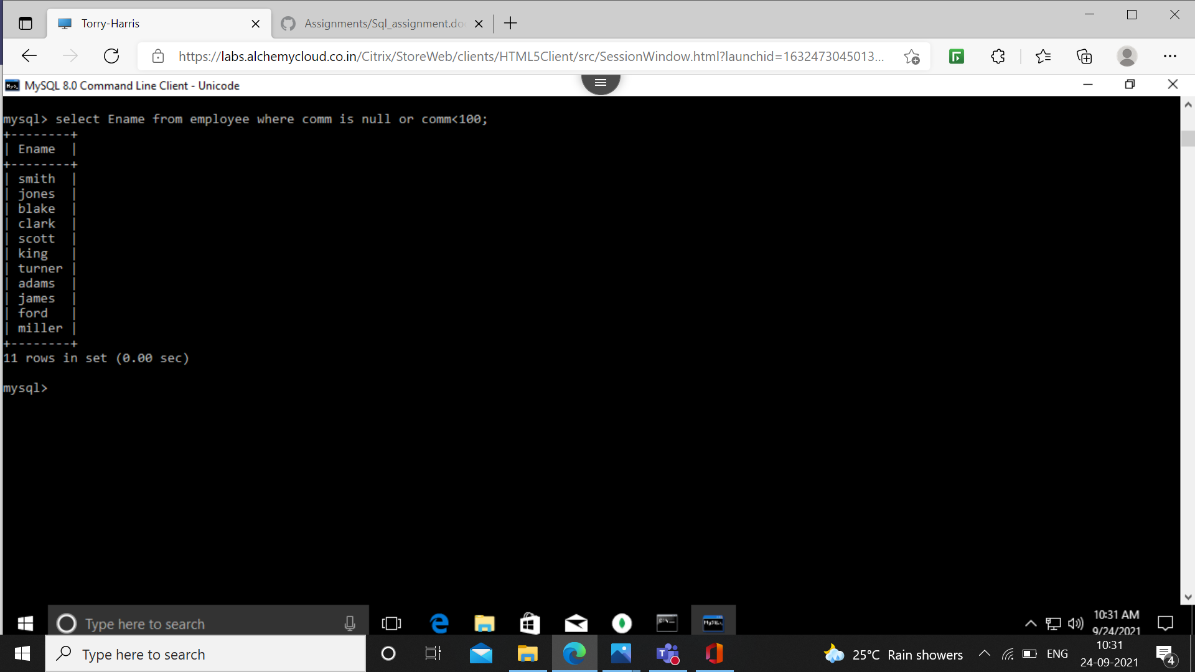

21.if all the employee's not receiving commission is entitled to a bonus of rs.250/- show the net earnings of all the employees

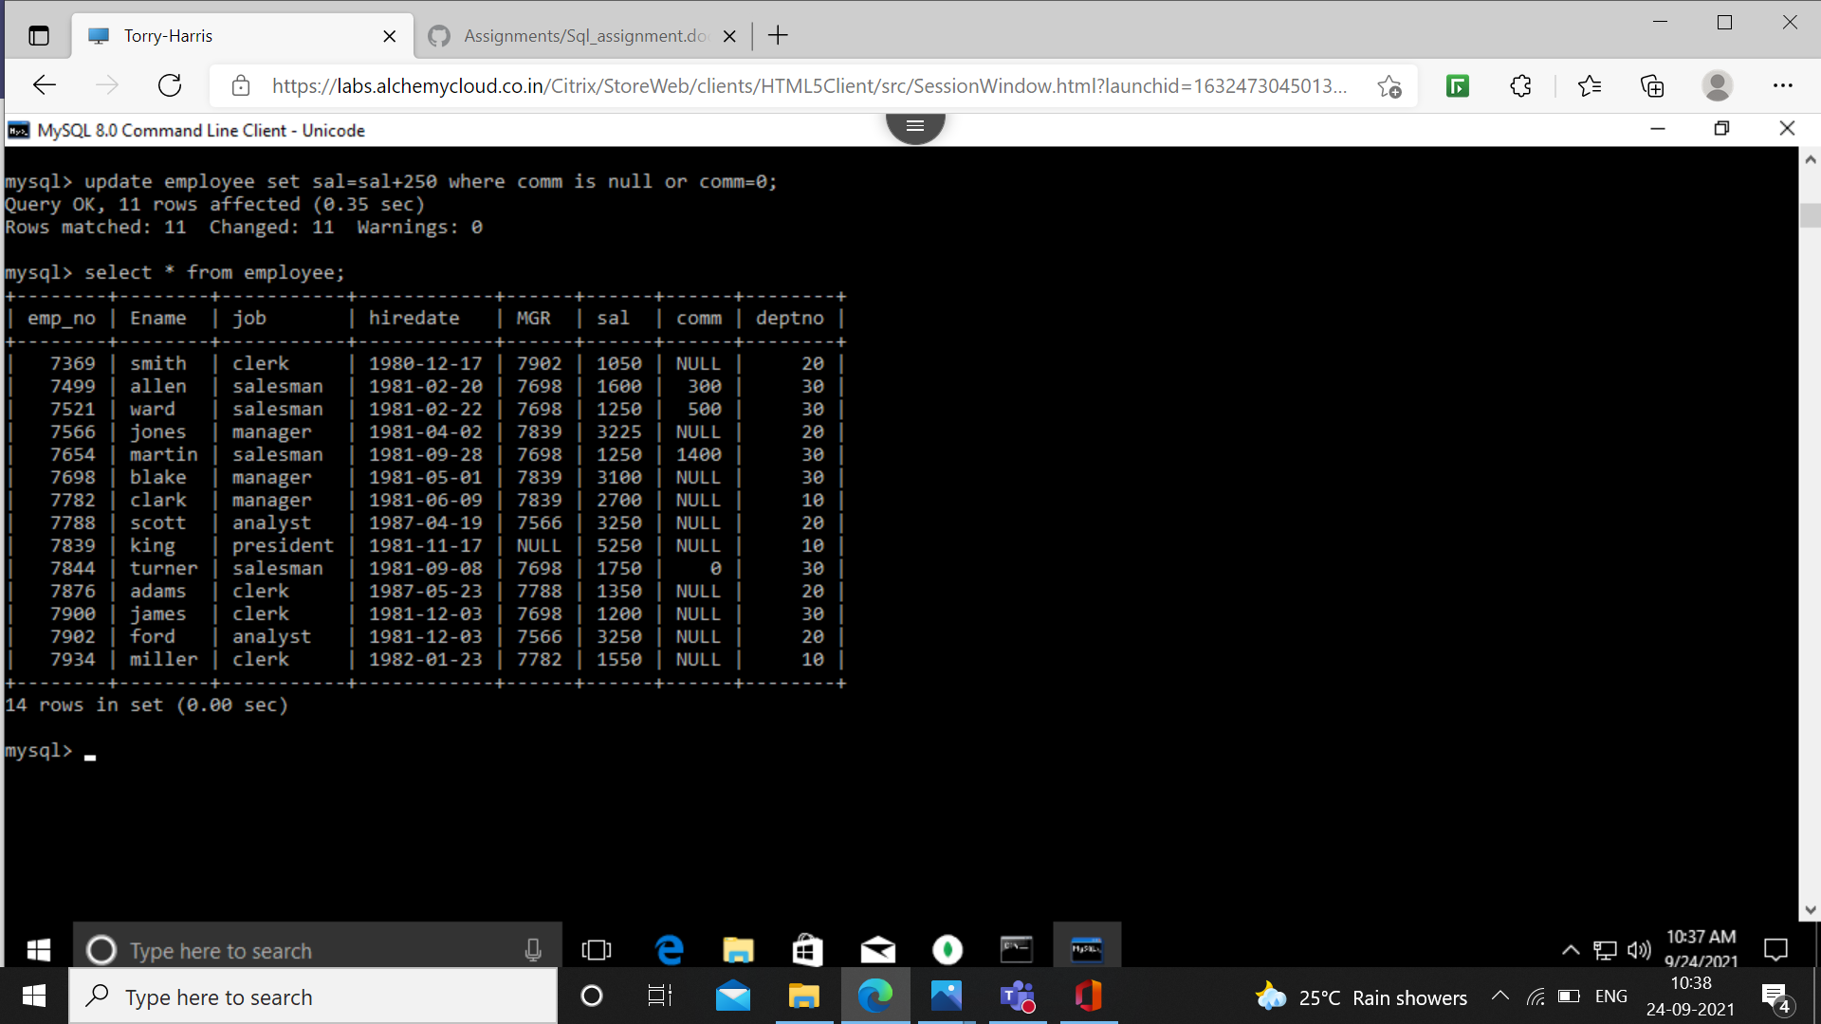

22. Find all the employees whose total earning is greater then 2000/-

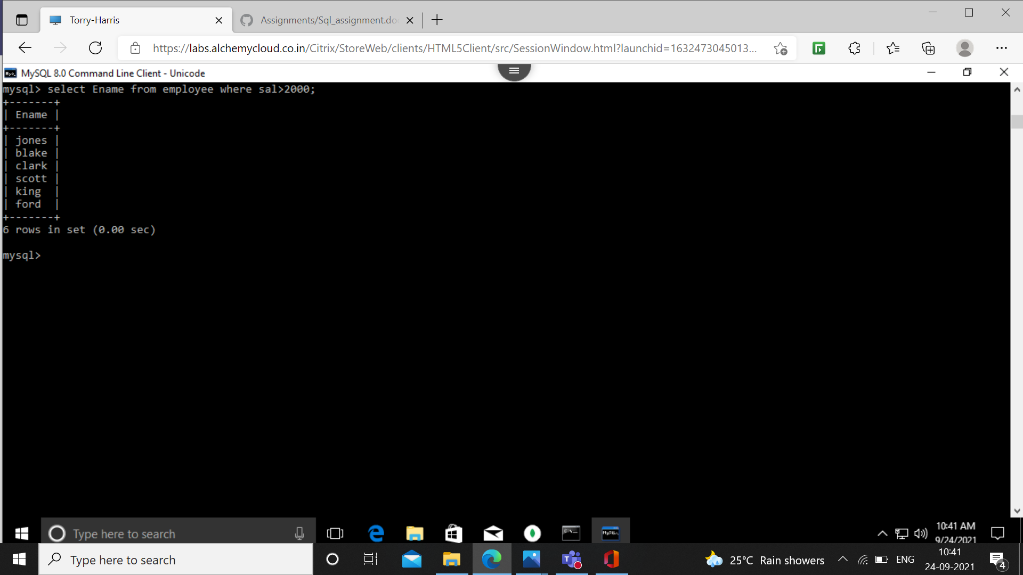

23. Find all the employees whose name begins or ends with ‘M’.

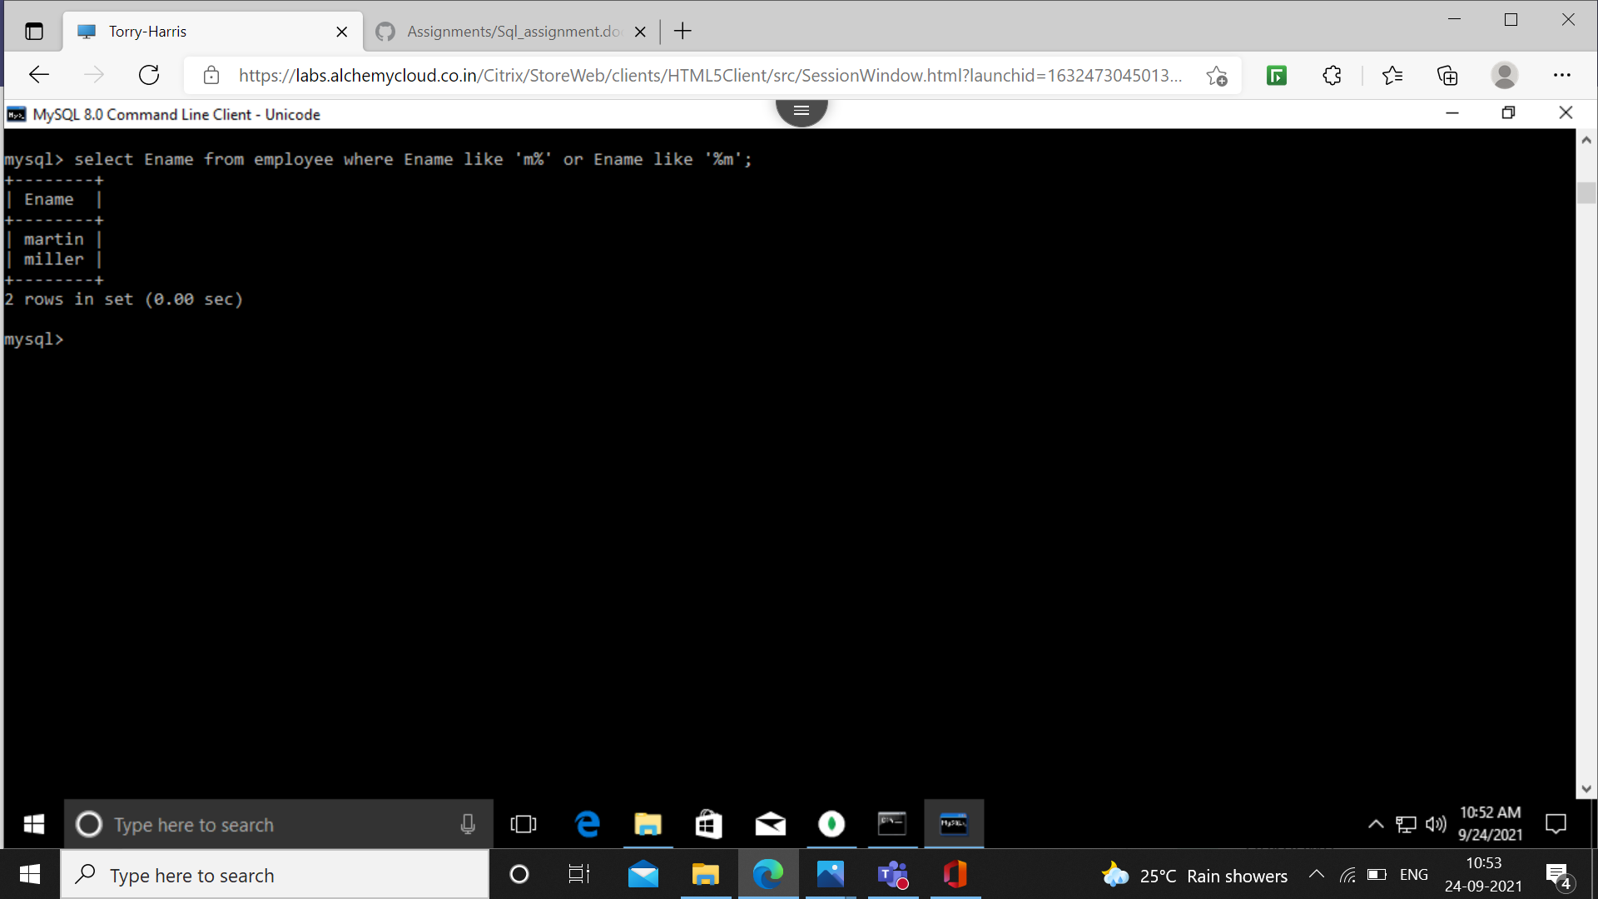

24. Find all the employees whose names contain the letter m in any case.

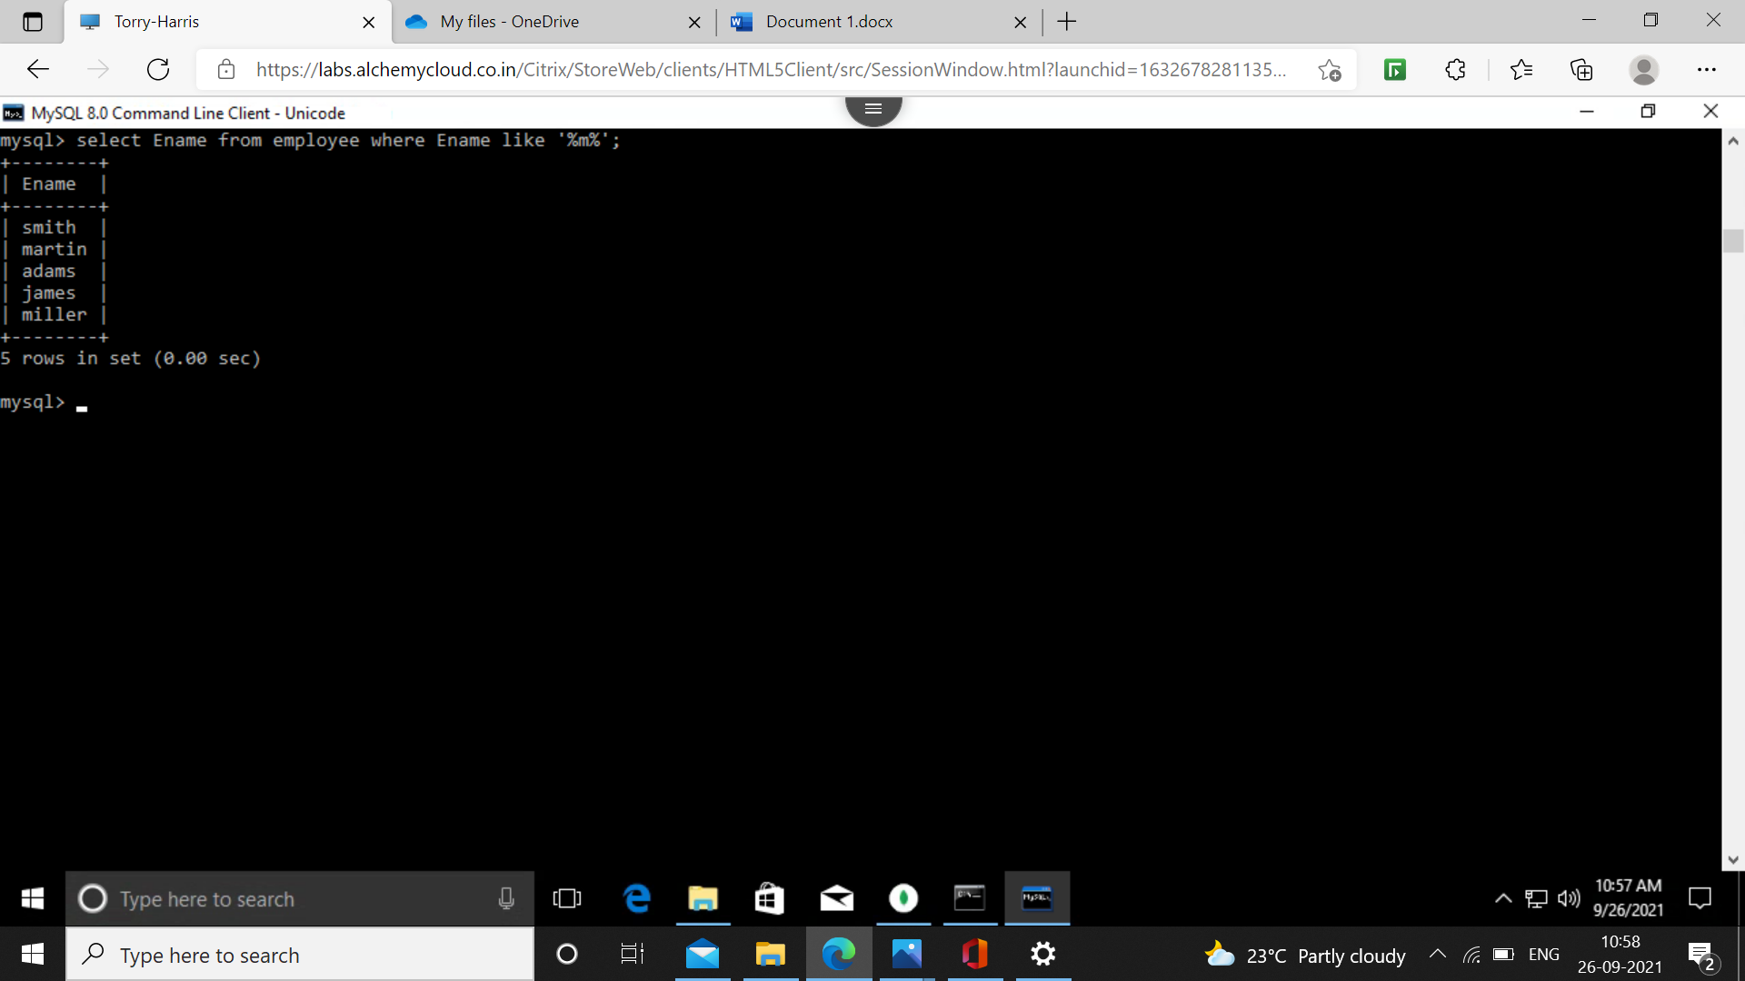

25. Find all the employees whose names are up to 15 characters long and have letter ‘r’ as their third character of names.

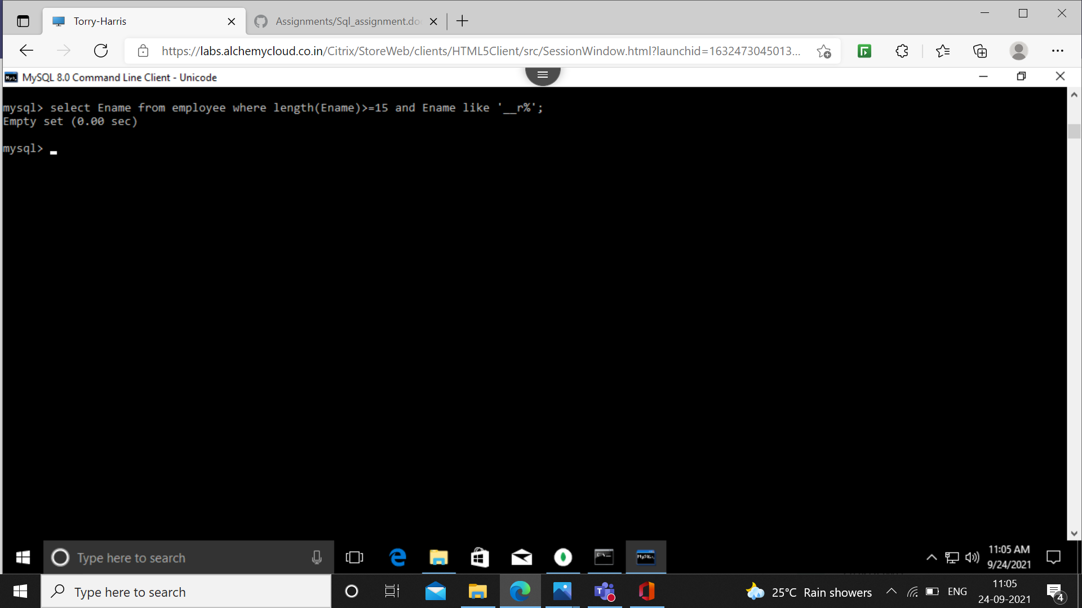

26. Find all the employees who were hired in the month of February.

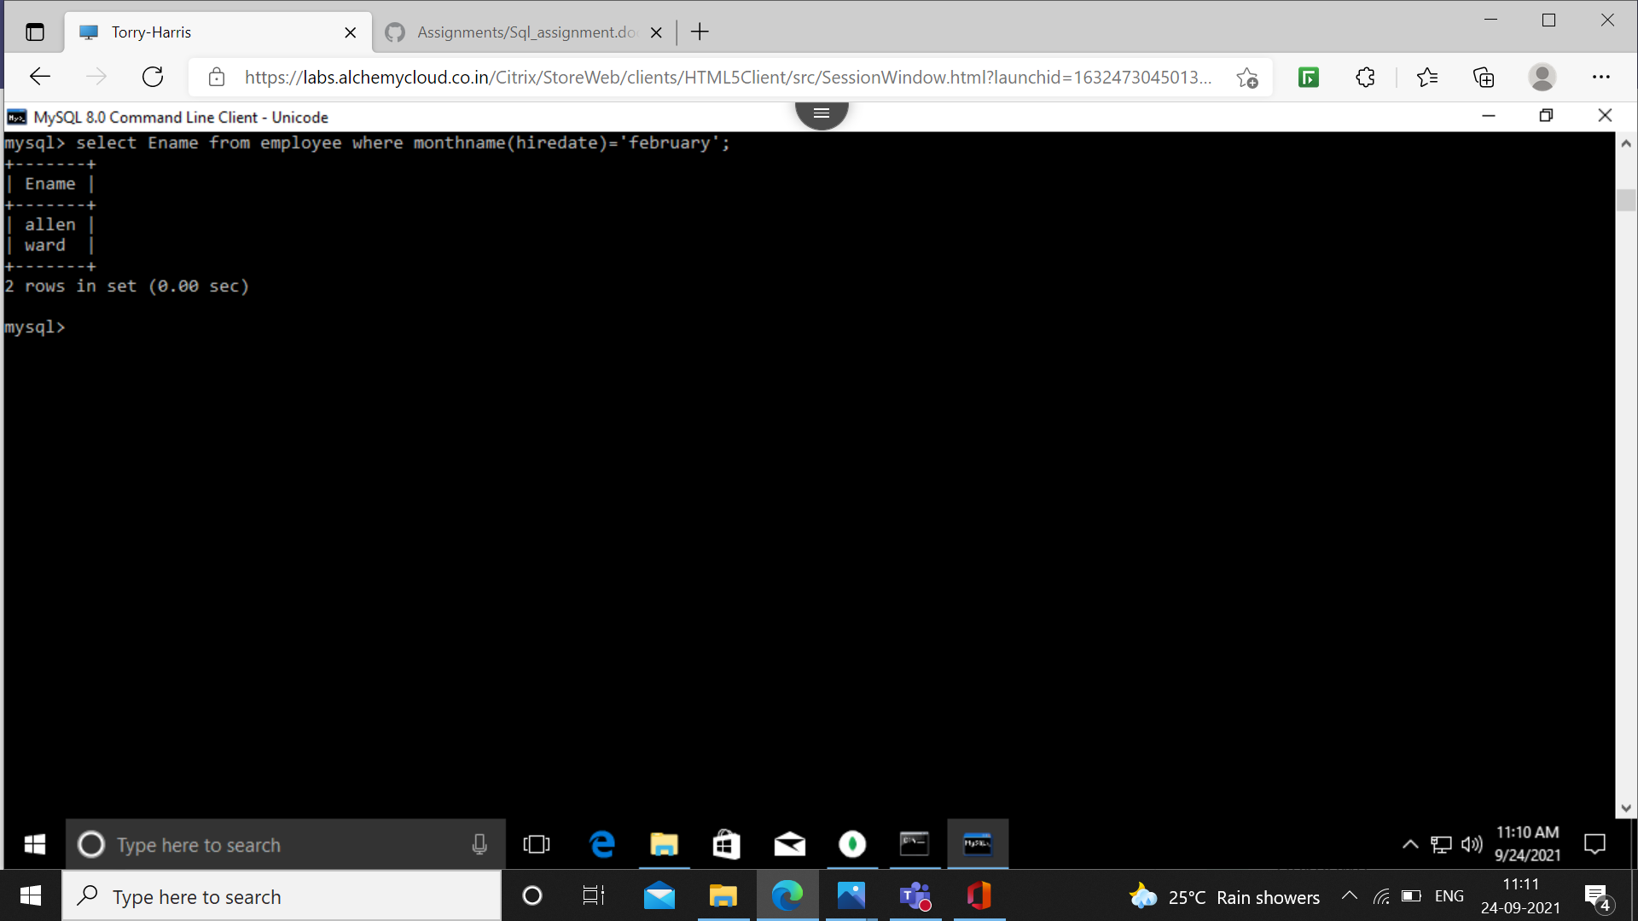

27.find all the employees who were hired on the last day of the month.

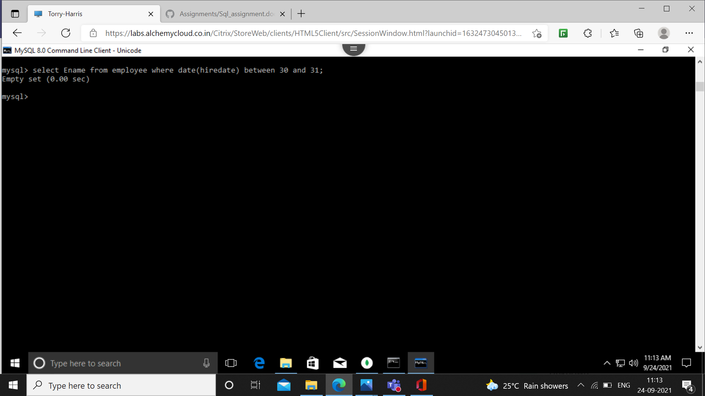

28. Find all the employees who were hired more than 2 years ago.

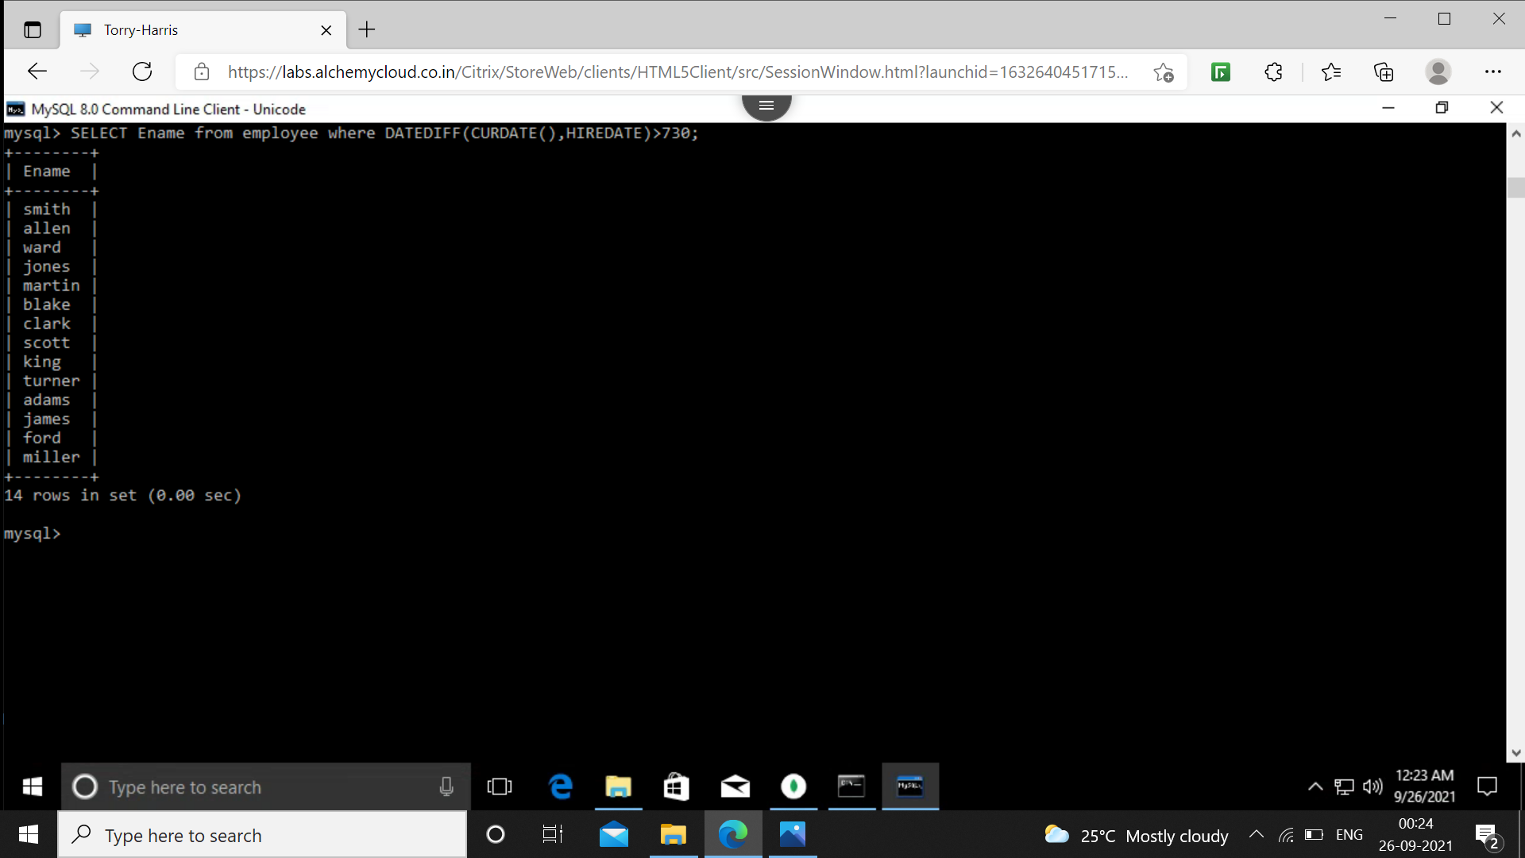

29. Find the managers hired in the year 2003.

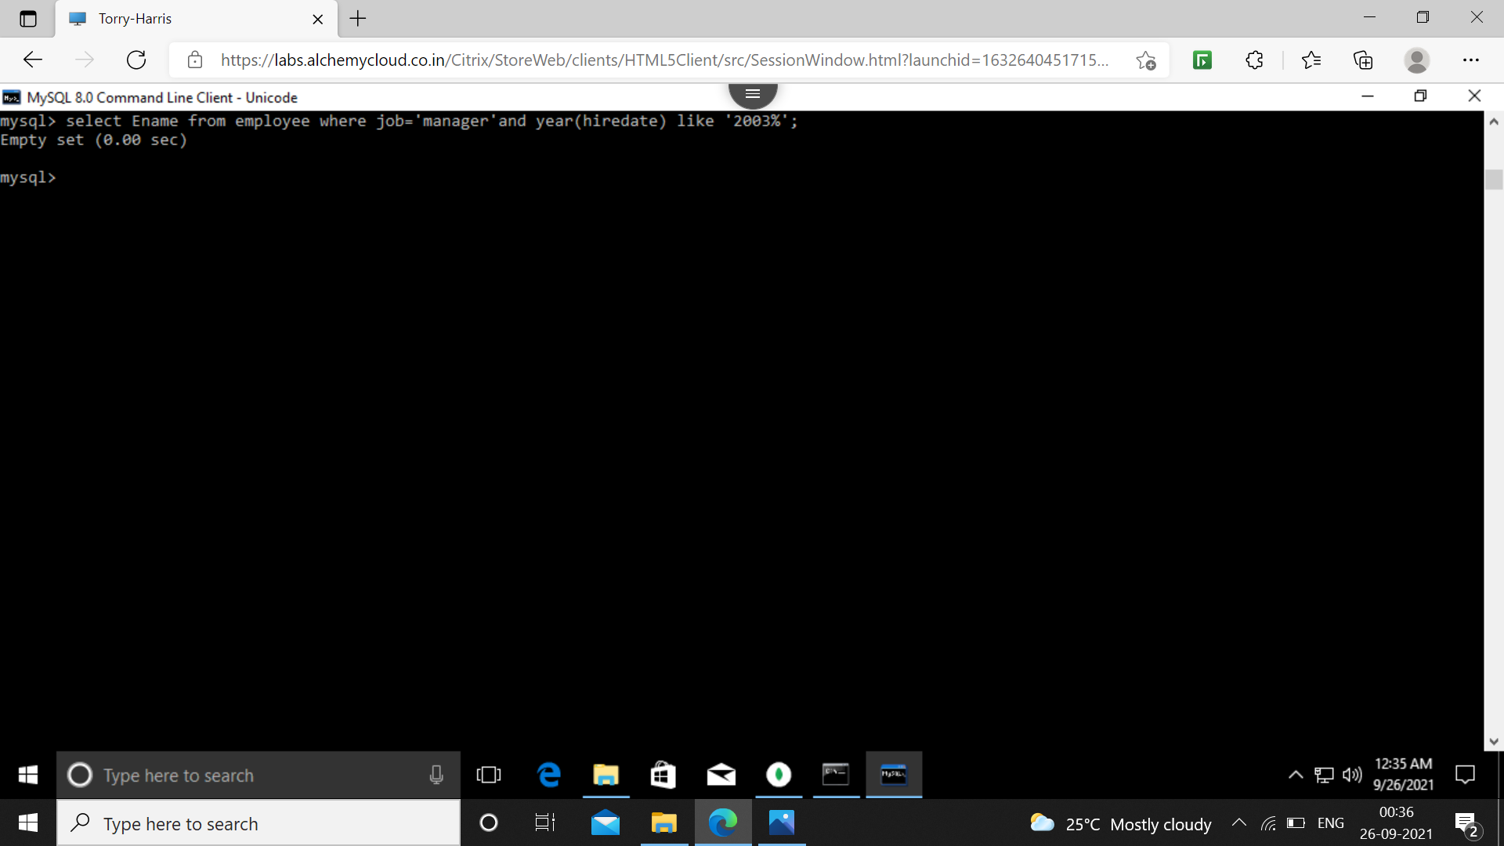

30. Display the names and jobs of all the employees separated by a space.

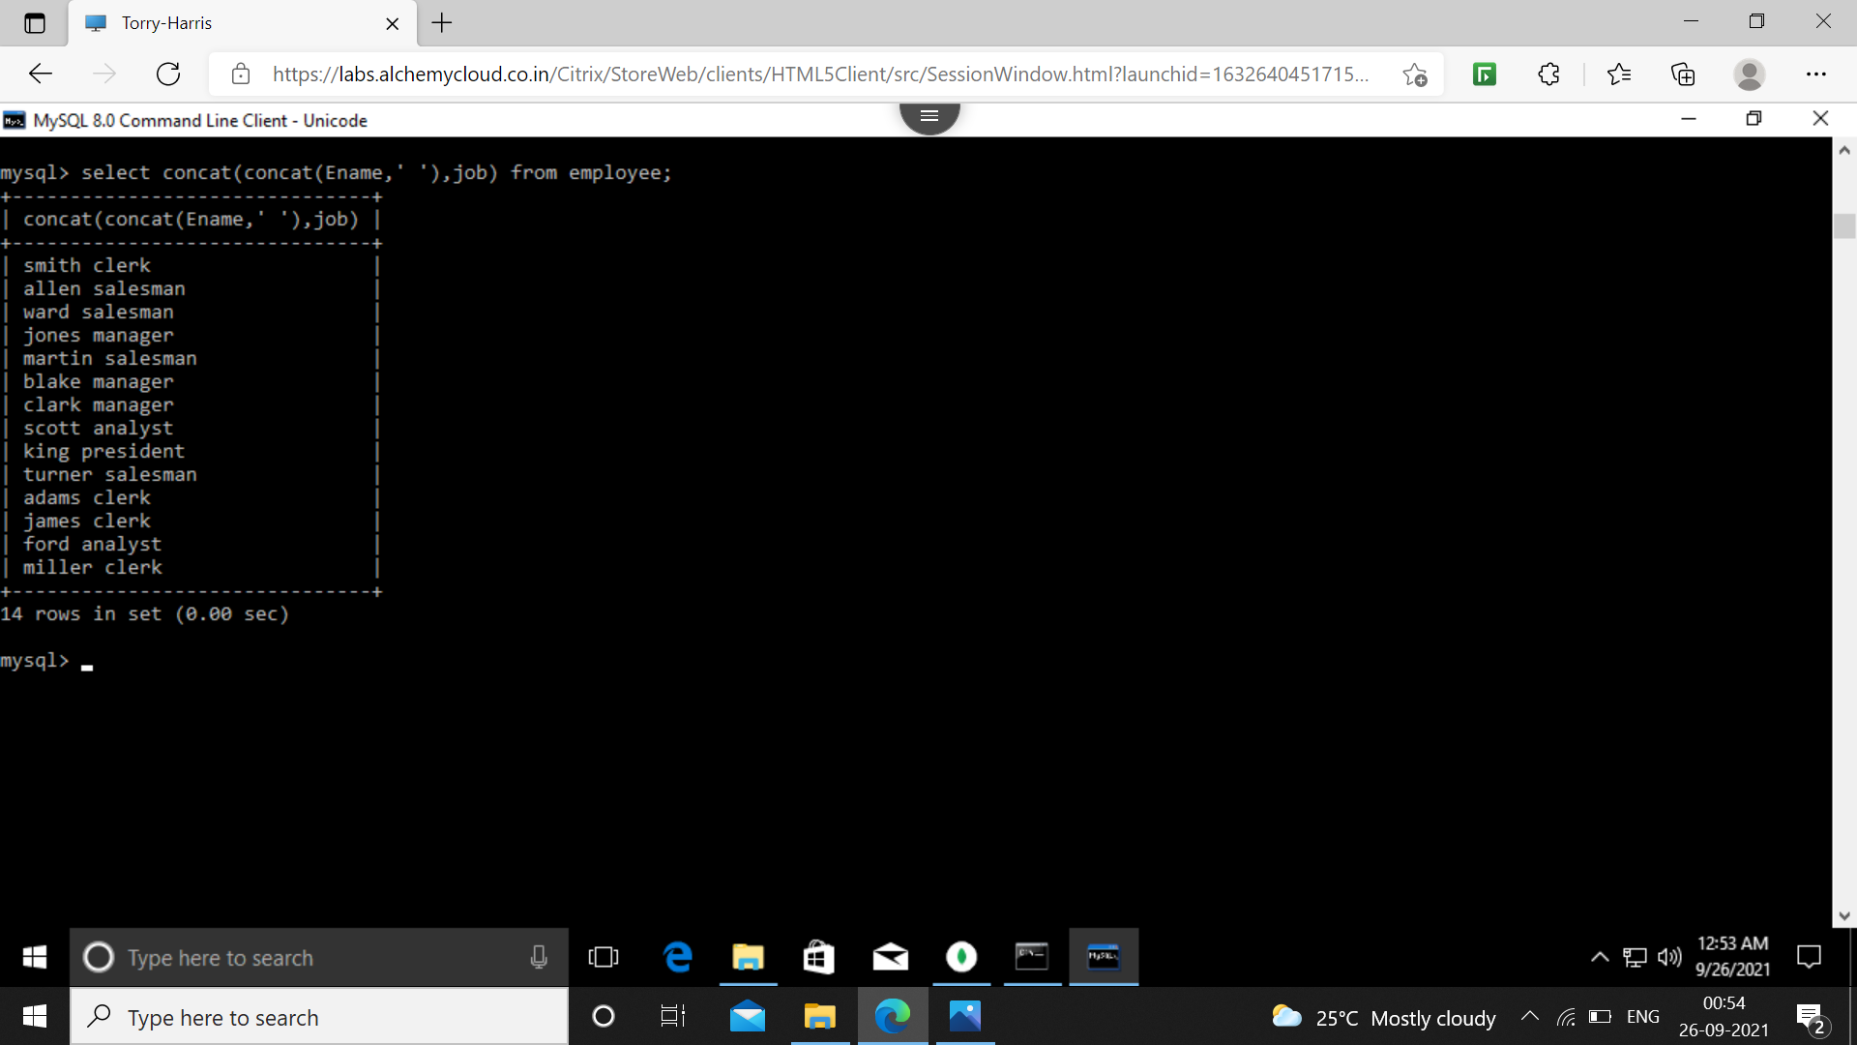

31. Display the names of all the employees right aligning them to 15 characters.

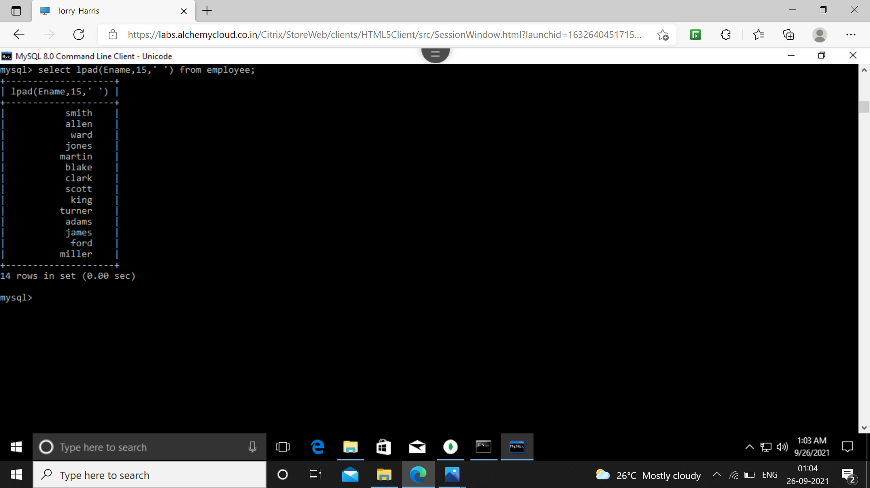

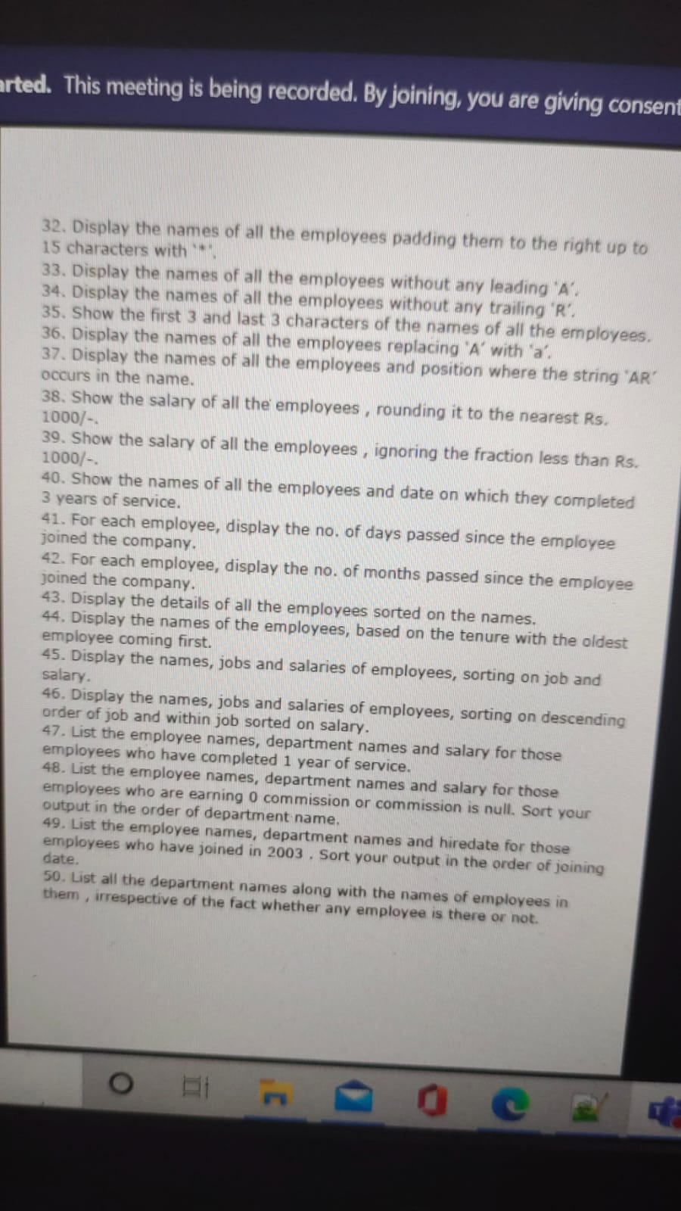

32. Display the names of all the employees padding them to the right up to 15 characters with ‘\*’.

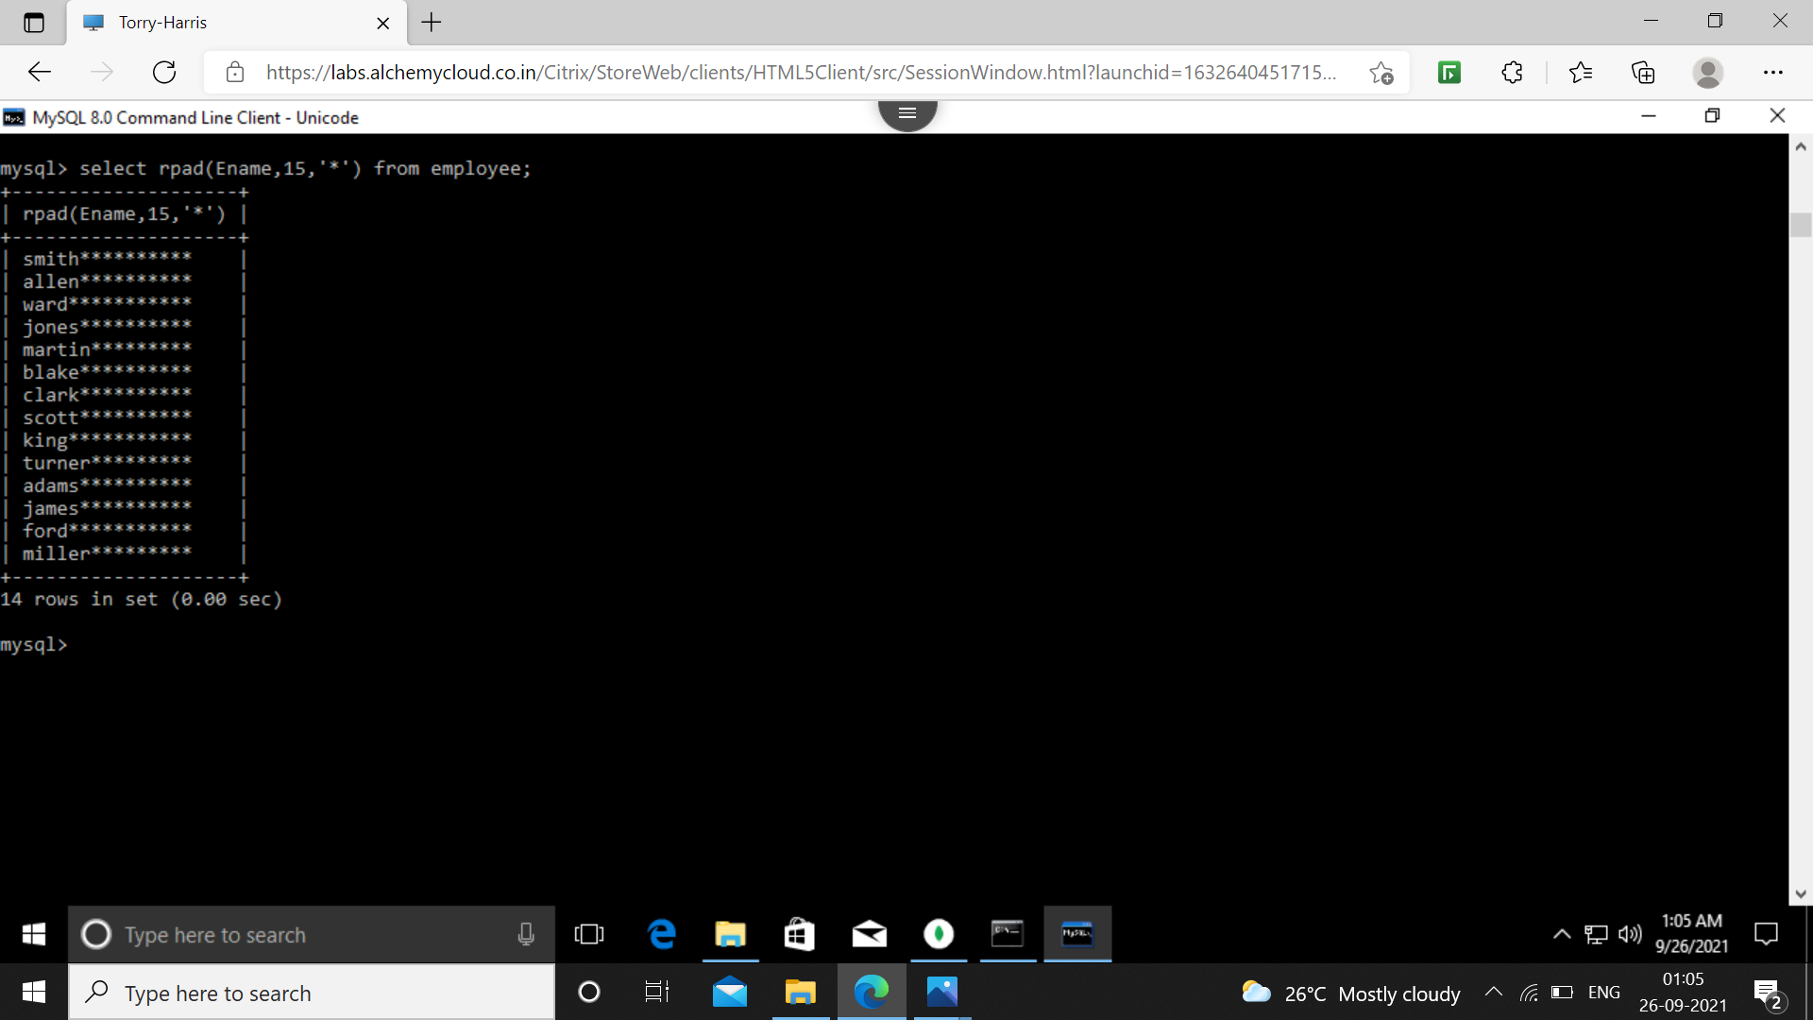

33. Display the names of all the employees without any leading a.

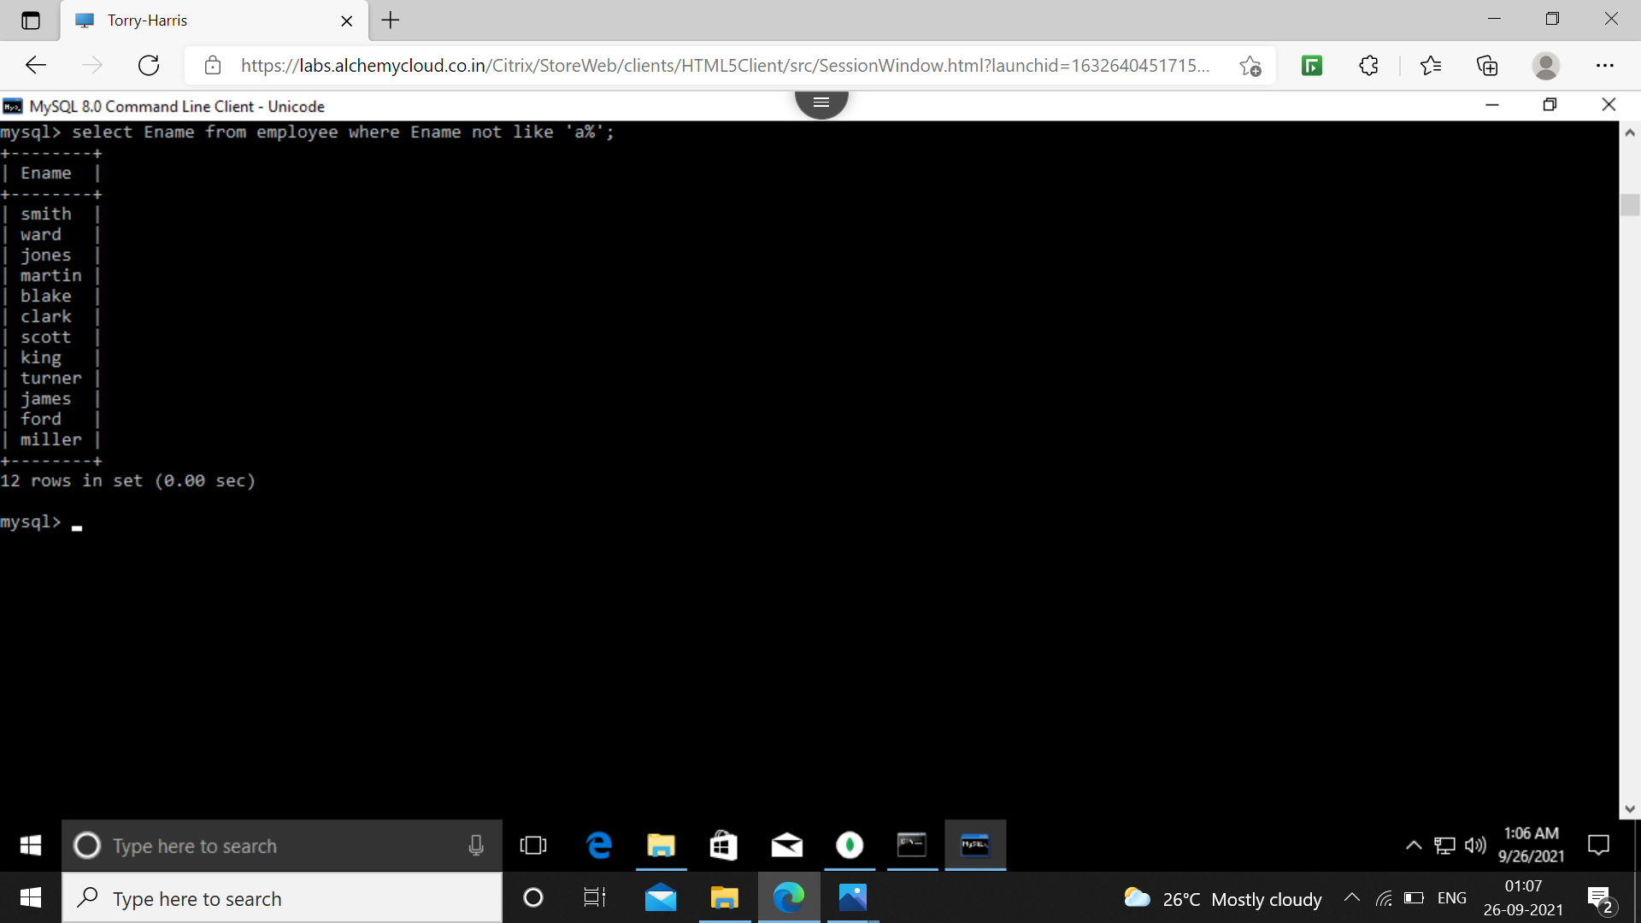

34. Display the names of all the employees without any leading r.

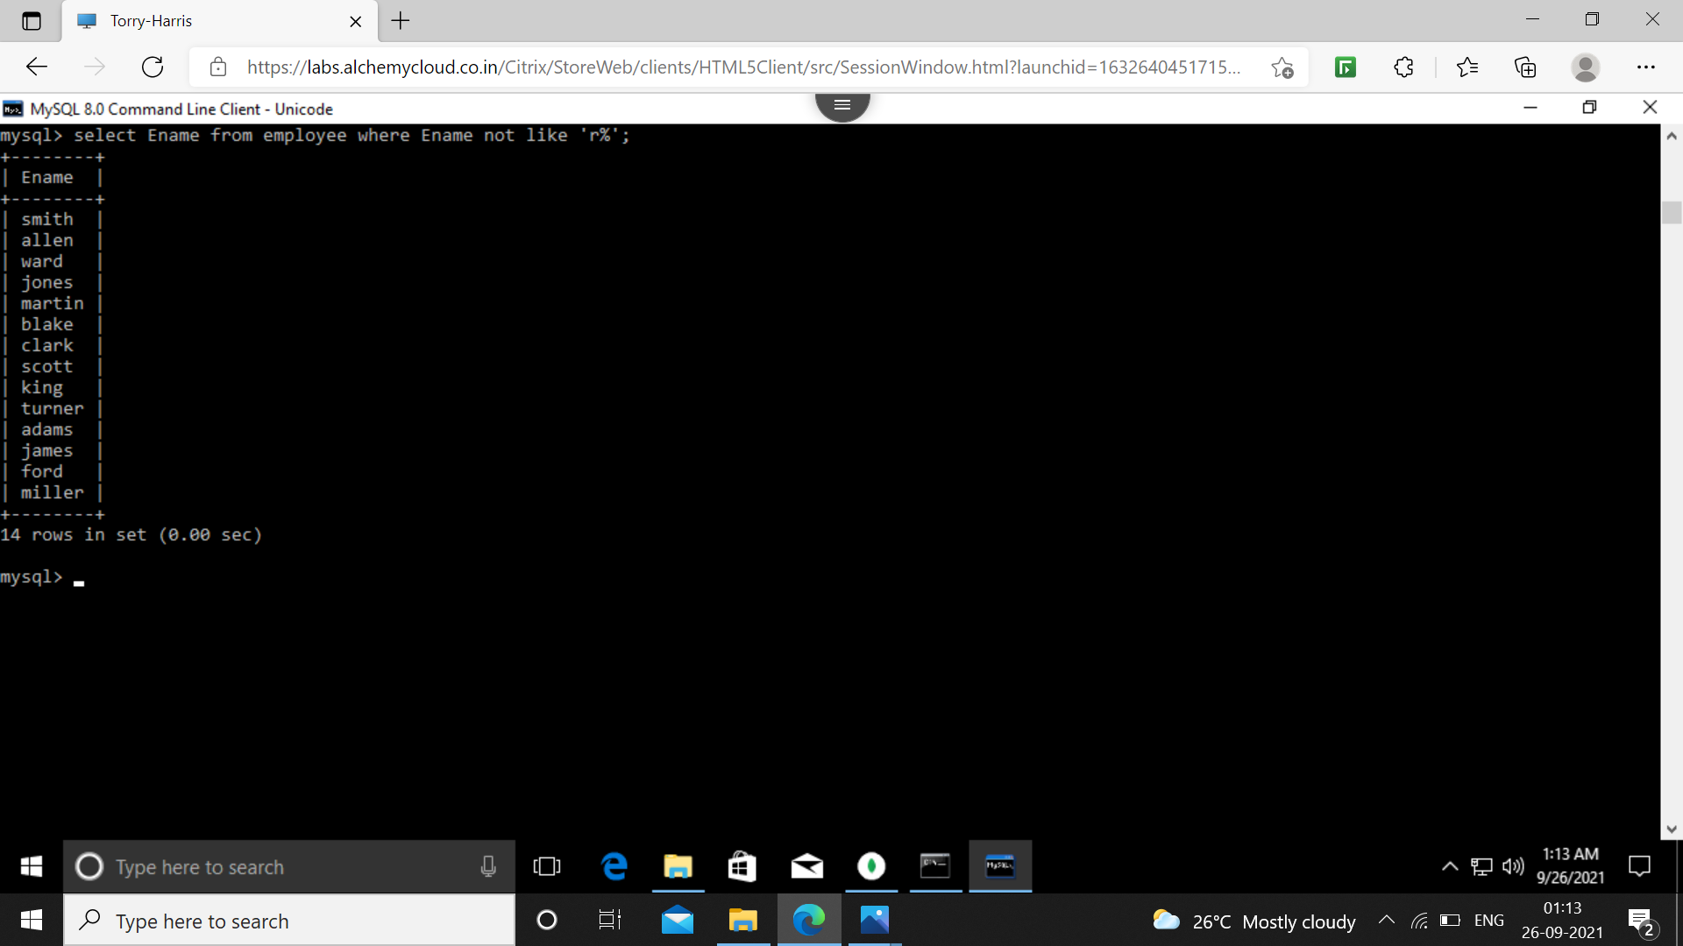

34. Display the names of all the employees without any trailing r.

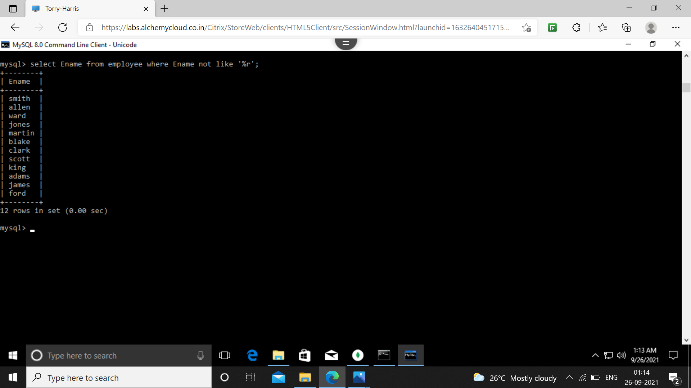

35. Show the first three and last 3 characters of the names of all the employees.

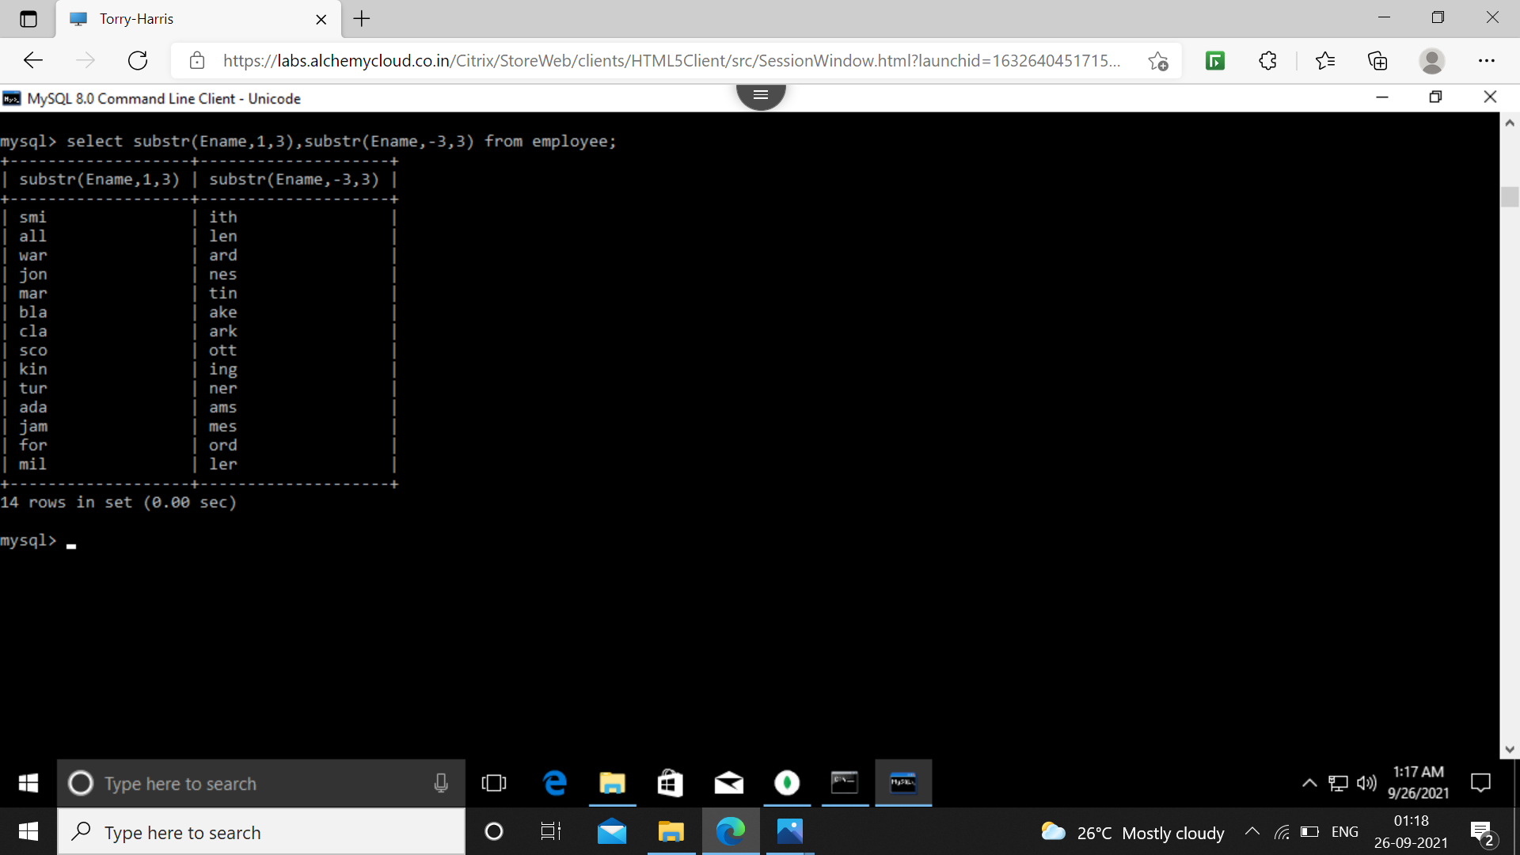

36. Display the names of all the employee's replacing ‘A’ with ‘a’.

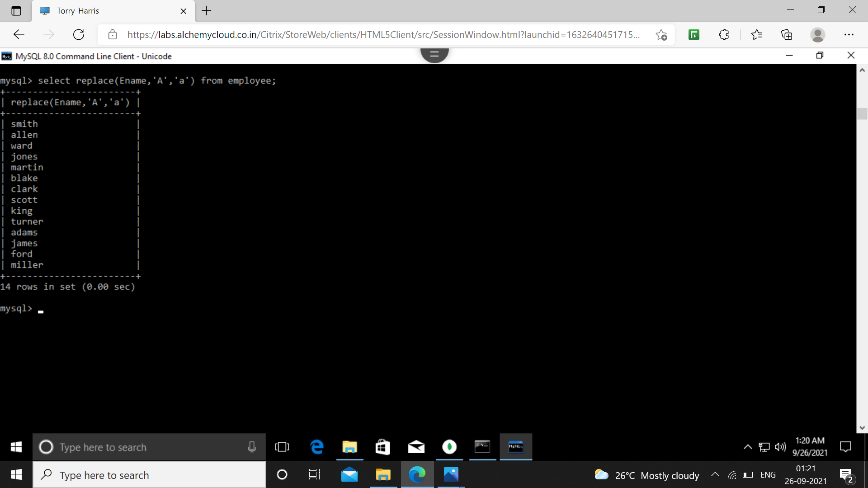

37. Display the names of all the employees and position where the string ‘AR’ occurs in the name.

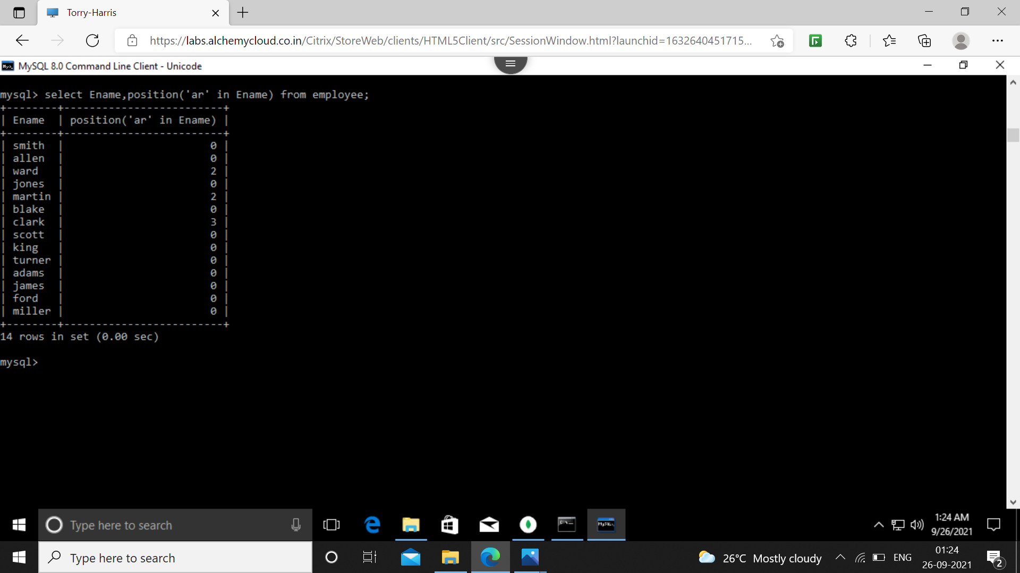

38.show the salary of all the employees, rounding it to the nearest 1000/-

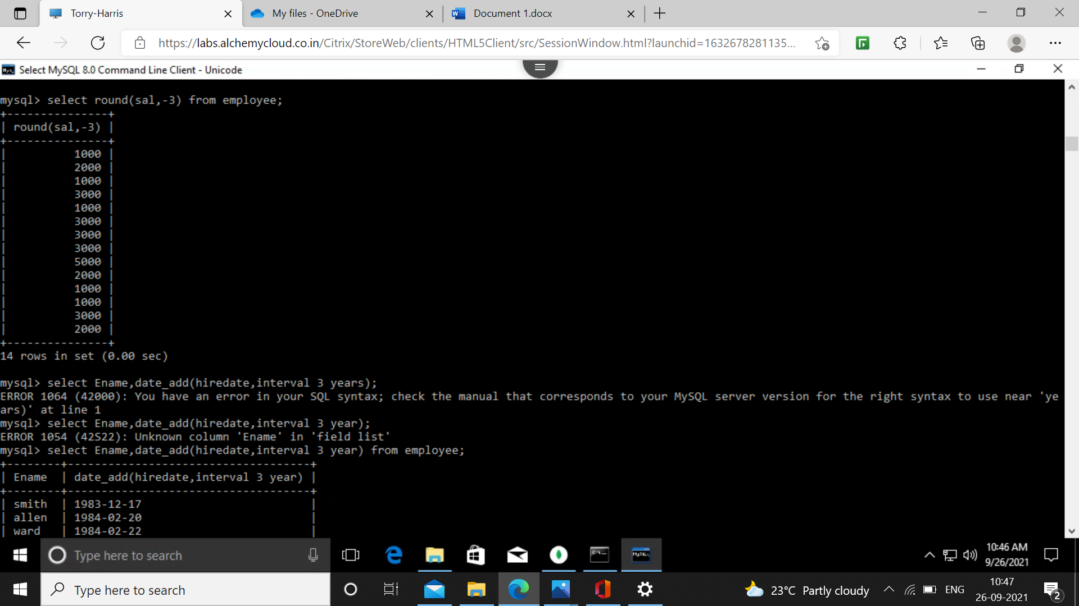

40. Show the names of all the employees and the date on which they completed 3 years of service.

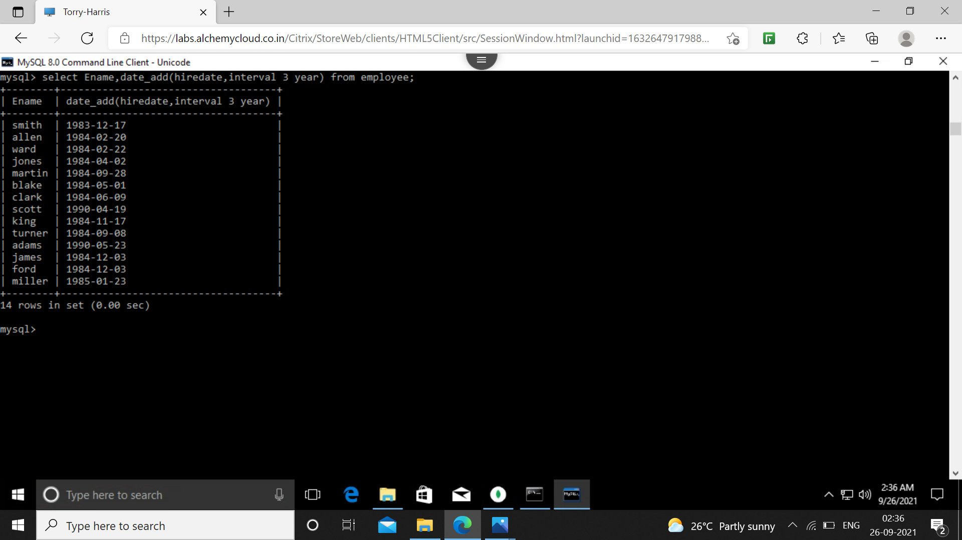

41.For each employee display the number of days passed since the employee joined the company.

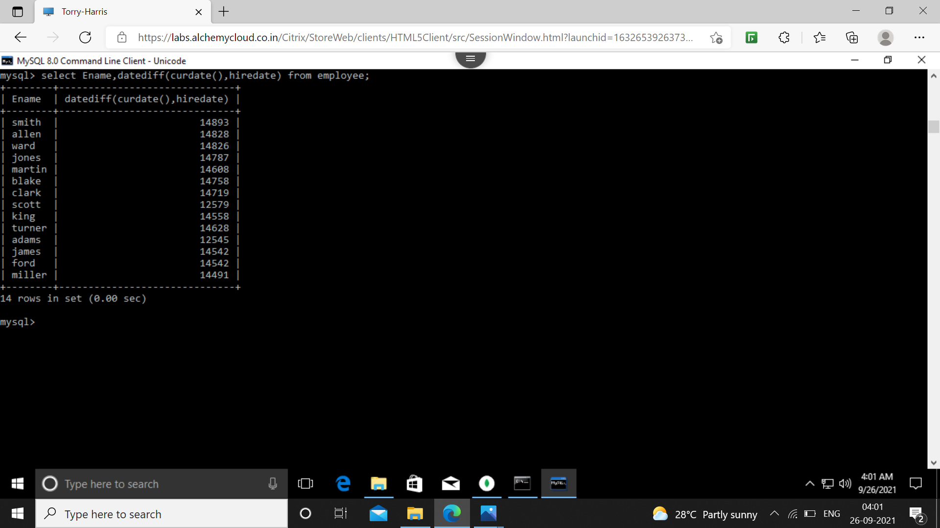

43.display the details of all the employees sorted on the names.

